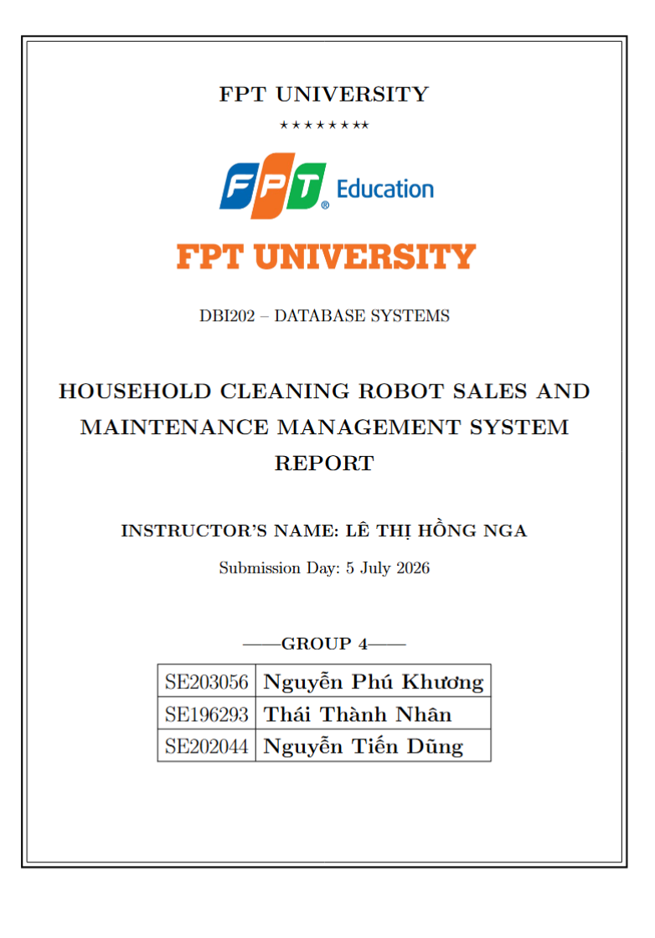

Table of Contents

Contents
Table of Contents 1
I. Lab 1 - Data Model Study 2
1. Objective 2
2. Study of Data Models 2
2.1. Relational Data Model 2
2.2. Semi-structured Data Model (XML/JSON) 3
2.3. NoSQL Models 4
3. Model Selection for Group Project (Household Cleaning Robot System) 6
4. Conclusion & Reflection 7
II. Lab 2 - Entity Analysis, Attributes, FDs and Keys 7
1. Objective 7
2. Entity Analysis, Attributes, FDs and Keys 7
2.1. User Management Entity Group 7
2.2. Product & Inventory Management Entity Group 8
2.3. Sales & Transactions Management Entity Group 9
2.4. Maintenance, Repair & IoT Extension Entity Group 11
3. Conclusion and Reflection 12
III . Lab 3 - Anomaly Detection and Normalization 13
1. Objective 13
2. Analysis of Anomalies 13
2.1. Redundancy Analysis 13
2.2. Update Anomalies 14
2.3. Insertion Anomalies 15
2.4. Deletion Anomalies 15
3. Identification of Normal Forms 16
3.1. First Normal Form (1NF) 16
3.2. Second Normal Form (2NF) 17
Third Normal Form (3NF) 18
3.4. Boyce–Codd Normal Form (BCNF) 20
4. Step-by-Step Decomposition 22
Step 1: Decompose Payment to Eliminate Structural Redundancy 22
Step 2: Simplify OrderDetail Primary Key 23
Step 3: Decompose Multi-Valued Attributes (1NF Enforcement) 23
5. Final Normalized Schema 25
5.1. User Management 25
5.2. Product & Inventory Management 25
5.3. Sales & Transactions Management 25
5.4. Maintenance, Repair & IoT Extension 26
5.5. How Anomalies Are Eliminated 26
6. Conclusion 27
IV. Lab 4 - Relational Database Design Process 27
1. Objective 27
2. Conceptual Model (ERD) 28
2.1. Entities and Attributes 28
2.2. Relationships and Cardinalities 30
3. Logical Model 32
3.1. Relational Schema 32
3.2. Primary Keys and Foreign Keys 34
3.3. M:N Relationship Resolution 35
4. Physical Model 36
4.1. Table Definitions with Data Types 36
5. Constraints 42
5.1. Column-Level Constraints 42
5.2. Table-Level Constraints 44
6. Conclusion and Reflection 47
V. Lab 5 - SQL Queries, View, Index, Functions, Procedures, and Triggers 48
1. Objective 48
2. Database Design (from Lab 4) 48
3. SQL Queries 51
3.1. Basic Queries 51
SELECT queries over entire tables 51
Filtering data with WHERE 54
Sorting with ORDER BY 59
Aggregate functions (COUNT, SUM, AVG, MAX, MIN) 63
3.2. Intermediate Queries 66
Joining multiple tables (INNER JOIN / LEFT JOIN) 66
Grouping with GROUP BY and HAVING 71
Subqueries in WHERE / FROM 75
3.3. Advanced Queries 79
Nested subqueries 79
Using EXISTS, IN, ANY/ALL 81
Set operations (UNION / INTERSECT / EXCEPT) 83
4. Functions 87
5. Stored Procedures 90
6. Triggers 97
7. Views and Indexes 101
Views - simplifying complex queries 101
Indexes - speeding up queries 103
8. Conclusion and Reflection 105

I. Lab 1 - Data Model Study

1. Objective
The purpose of this lab is to explore and analyze existing data models in database systems. Through this report, my group will gain a solid understanding of basic structures, constraints, data manipulation methods associated with each model, as well as their practical applications in solving softwarerelated problems.

2. Study of Data Models

2.1. Relational Data Model
- Storage structure: Data is organized into tables (Relations) consisting of rows (Tuples) and columns (Attributes).
- Constraints: Domain constraints; Key constraints (Primary Key); Entity integrity and Referential integrity (Foreign Key).
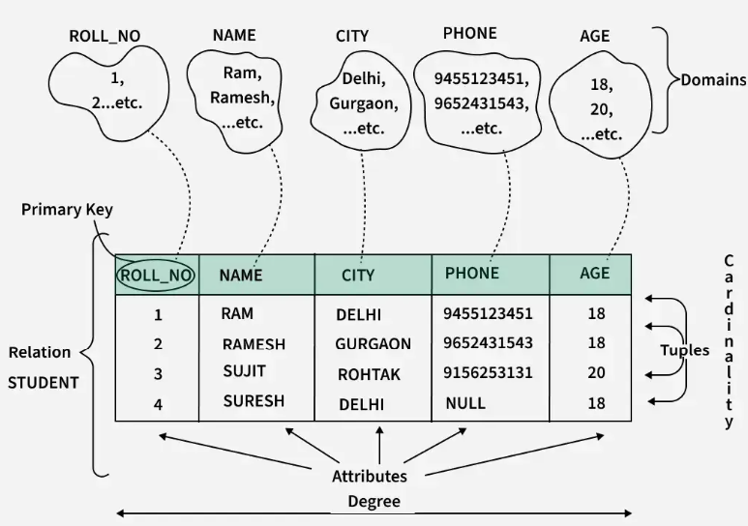
Example Relational Data Model in DBMS

- Data manipulation operators: Uses Relational Algebra or SQL language (SELECT, INSERT, UPDATE, DELETE) based on set theory.
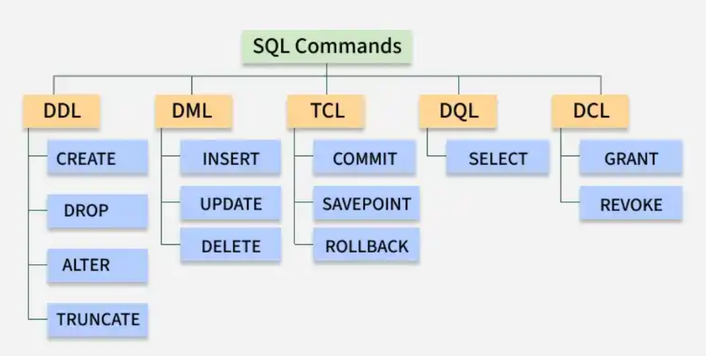
Example SQL language
- Advantages: High consistency, strict compliance with ACID principles, good data independence, and powerful standard query language (SQL).
- Limitations: Difficult horizontal scaling and reduced performance when executing complex JOIN queries on massive datasets.
- Suitable applications: Financial management systems (Banking, Securities), ERP, HR management, and traditional sales management systems.

2.2. Semi-structured Data Model (XML/JSON)
- Storage structure: Data does not follow a fixed table schema but is organized hierarchically, as trees or graphs through tags or nested key-value pairs (JSON, XML).
- Constraints: Very flexible. The schema may be self-describing within the data or loosely defined through XML Schema/JSON Schema.

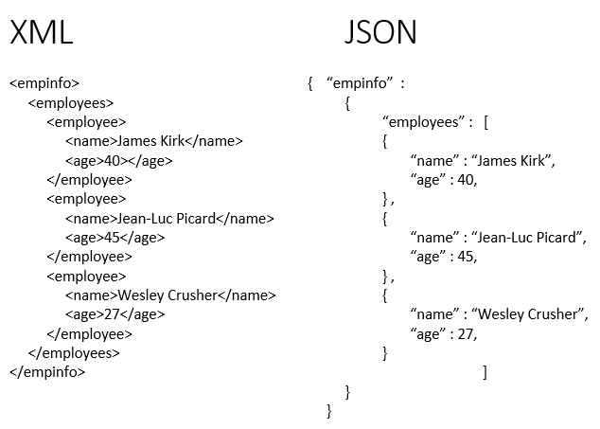
Example Json & XML

- Data manipulation: Uses languages such as XPath, XQuery for XML or JSONPath for JSON.
- Advantages: Highly flexible for storing heterogeneous data, easy to change structure, suitable for web data exchange.
- Limitations: Consumes more storage due to repeated metadata (tags, keys), and queries are more complex and less optimized than SQL on large datasets.
- Suitable applications: System configuration, data exchange between web APIs, and integration of data from multiple sources.
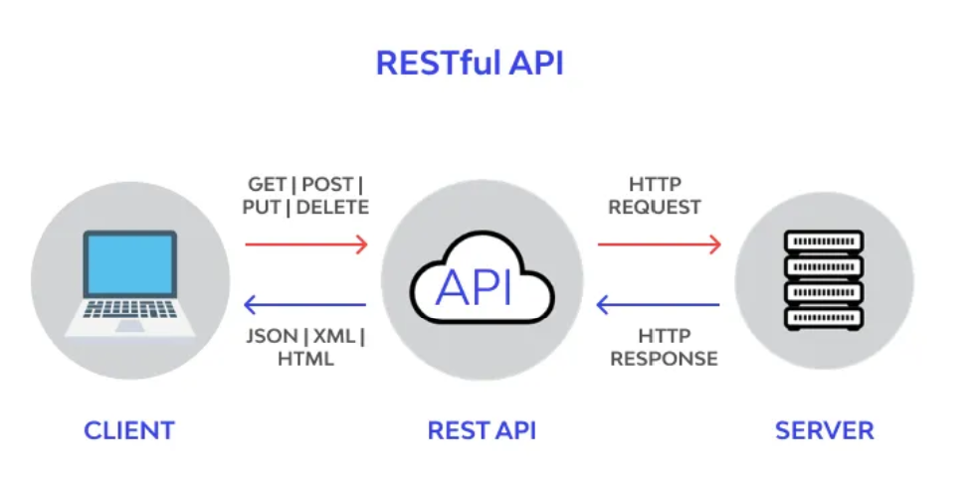

Examples of applications of Semi-structured Data Models

2.3. NoSQL Models
NoSQL Model | Structure & Constraints | Data Manipulation | Advantages / Limitations & Applications
Document-oriented | Stores data as Documents (JSON/BSON). Flexible schema. | CRUD via API with support for nested-field queries. | Flexible schema, good horizontal scaling.  Limited JOIN support and ACID compliance. Applications: CMS, Product Catalogs.
Key-Value Store | Stores data as Key-Value pairs. Keys must be unique. | GET(key), PUT(key, value), DELETE(key). Cannot query by value. | Extremely fast retrieval speed and easy scaling. Limited query capability. Applications: Redis caching, Session management.
Graph Database | Node (entity) and Edge (relationship). Constraints define relationship validity. | Graph traversal using Cypher (Neo4j) or Gremlin. | Excellent for multi-level relationships. Not suitable for large aggregate calculations. Applications: Social networks, Recommendation systems.
Column-family Store | Stores data in rows with dynamic columns. Organized into column families. Keyspace defines the schema. | Query by row key, column family, or column modifier using CQL (Cassandra Query Language) or API. | Advantages: High write throughput, mass scaling, compression efficiency.  Limitations: Complex data modeling, poor support for ad-hoc queries.  Applications: Time-series data, Analytics, IoT logging (e.g., Apache Cassandra, HBase).

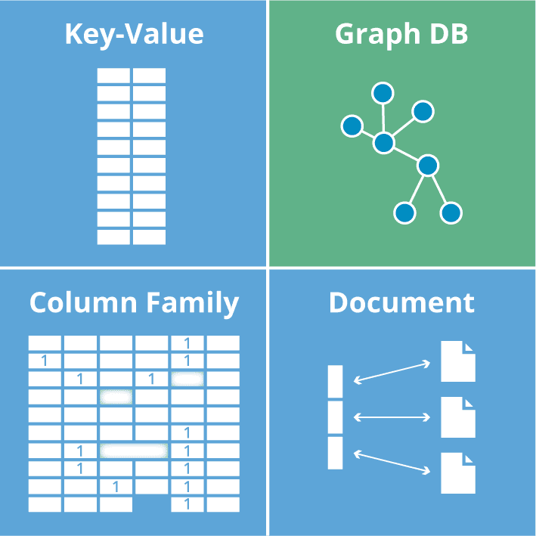
Example of NoSQL Model

3. Model Selection for Group Project (Household Cleaning Robot System)
- Project: Household Cleaning Robot Sales & Maintenance Management System. The team decided to use only the Relational Data Model for the entire system based on three core reasons:
- Ensuring business transaction integrity: Sales, warranty, and repair assignment processes require strict data constraints. The Foreign Key mechanism and ACID properties of relational databases ensure that order, payment, and inventory data are always absolutely accurate, without discrepancies or fragmentation.
- Optimizing multi-dimensional report generation: The system requires the generation of complex linked reports (sales, maintenance history, technician performance). SQL provides powerful query operators (JOIN, GROUP BY, aggregation functions) to quickly aggregate and analyze this data.
-Integrated system architecture (including IoT/AI): Instead of using additional NoSQL databases, robot error log data is standardized and stored directly in the DeviceLogs table (including LogID, RobotID, Time, and Data). This design allows the use of JOIN commands to directly connect device logs to customer records, supporting predictive maintenance scheduling analysis on a single, unified database platform, optimizing operational effort.

4. Conclusion & Reflection
Comprehensive research into data models provided the team with deep insights into the characteristics and application boundaries of each technology. For the intelligent cleaning robot management and maintenance system, the consistent application of the Relational Database Model was a strategic and practical decision. This choice perfectly met the core requirements of reliability and data integrity. The relational model is fully capable of effectively managing the flow of device monitoring data (IoT), creating a solid and secure foundation for the long-term development of the system.

II. Lab 2 - Entity Analysis, Attributes, FDs and Keys

1. Objective
The objective of this practical lab is to develop an in depth understanding of entities, attributes, functional dependencies , and keys within a database context. Through this report, the group will practice analyzing the data structure for the "Household Cleaning Robot Sales & Maintenance Management System" project, identifying relationships to ensure data integrity.

2. Entity Analysis, Attributes, FDs and Keys
The "Household Cleaning Robot Sales & Maintenance Management System" is structured around four core functional modules: User Management, which handles customer and employee data; Product & Inventory Management, which tracks robot models and individual units, Sales & Transactions Management, which covers orders, payments, and warranty registrations, and Maintenance, Repair & IoT Extension, which manages service requests, maintenance records, and device logs. The following section provides a detailed analysis of the entities, attributes, functional dependencies, and keys within each module.

2.1. User Management Entity Group
Entity: Customer
- Description: This entity manages all external client identities within the system. Data is gathered from the online customer registration form and account profile settings. It maintains essential personal profiles, communication details, and encrypted login credentials, serving as the foundational anchor for product sales, warranty registrations, and after-sales service requests.
- Attributes: CustomerID, FullName, PhoneNumber, Email, Address, Password.
- Functional Dependencies :
+ CustomerID → FullName, PhoneNumber, Email, Address, Password
+ Email → CustomerID
+ PhoneNumber → CustomerID
- Candidate Keys: CustomerID, Email, PhoneNumber
- Primary Key: CustomerID
Entity: Employee (including Admin, Sales, Technician)
- Description: This entity represents the internal workforce roster, encompassing all system user roles including Administrators, Sales Staff, and Maintenance Technicians. Collected from internal HR assignment logs, it centralizes staff profiles and authentication details, enabling secure role based access control (RBAC) to ensure employees can only execute features mapped to their specific operational duties.
- Attributes: EmployeeID, FullName, Role, PhoneNumber, Email, Password.
- Functional Dependencies :
+ EmployeeID → FullName, Role, PhoneNumber, Email, Password
+ Email → EmployeeID
- Candidate Keys: EmployeeID, Email
- Primary Key: EmployeeID

2.2. Product & Inventory Management Entity Group
Entity: RobotModel (Robot Category/Model)
- Description: This entity acts as the centralized master product catalog for all household cleaning appliances handled by the business. Sourced from official manufacturer product specification sheets and e-commerce browsing pages, it archives static design data—such as structural features, engineering specifications, baseline unit pricing, and standard warranty durations—shared across all physical units of a specific line.
- Attributes: ModelID, Brand, ModelName, Features, Specifications, UnitPrice, WarrantyDuration.
- Functional Dependencies :
+ ModelID → Brand, ModelName, Features, Specifications, UnitPrice, WarrantyDuration
+ ModelName → ModelID
- Candidate Keys: ModelID, ModelName
- Primary Key: ModelID
Entity: RobotUnit (Device/Inventory Unit)
- Description: This entity tracks individual, physical serialized hardware assets currently resting in inventory or deployed in customer households. Sourced from physical product serial-number stickers and warehouse stock inventory logs, it bridges the gap between a conceptual product model and a unique piece of operational hardware, actively monitoring its real-time lifecycle status (Available, Sold, or Under Maintenance).
- Attributes: RobotID, ModelID, SerialNumber, Status (Available/Sold/Maintenance).
- Functional Dependencies :
+ RobotID → ModelID, SerialNumber, Status
SerialNumber → RobotID, ModelID, Status
- Candidate Keys: RobotID, SerialNumber
- Primary Key: RobotID

2.3. Sales & Transactions Management Entity Group
Entity: SalesOrder
- Description: This entity captures the high-level transactional metadata of a commercial retail agreement between a customer and the business. Sourced from checkout invoices and sales receipt layouts, it logs the purchasing event, binds the customer and the handling sales staff member to the transaction, and tracks critical payment milestones through order status indicators.
- Attributes: OrderID, CustomerID, EmployeeID, OrderDate, TotalAmount, OrderStatus.
- Functional Dependencies :
+ OrderID → CustomerID, EmployeeID, OrderDate, TotalAmount, OrderStatus
- Candidate Keys: OrderID
- Primary Key: OrderID
Entity: OrderDetail
- Description: This entity functions as an itemized line-item ledger that breaks down the specific individual physical components contained within a larger sales order. Modeled from itemized retail invoice receipts, it pairs specific physical robot units to their respective sales transactions and locks in the final customized historical selling price, accommodating seasonal discounts or bundle adjustments.
- Attributes: OrderID, RobotID, SellingPrice.
- Functional Dependencies :
+ OrderID, RobotID → SellingPrice
+ RobotID → OrderID
- Candidate Keys: RobotID, {OrderID, RobotID}
- Primary Key: {OrderID, RobotID}
Entity: Payment
- Description: This entity handles the financial ledger entries tracking all incoming monetary revenue generated by the system. Modeled after commercial banking confirmation sheets and online checkout point-of-sale (POS) receipts, it records the exact amount, date, and processing method of a transaction, featuring flexible foreign key bindings to handle clear closures for both retail sales orders and technical service records.
- Attributes: PaymentID, OrderID, ServiceRecordID, Amount, PaymentDate, PaymentMethod.
- Functional Dependencies :
+ PaymentID → OrderID, ServiceRecordID, Amount, PaymentDate, PaymentMethod
- Candidate Keys: PaymentID
- Primary Key: PaymentID
Entity: WarrantyRegistration
- Description: This entity manages the legal operational timelines governing product protection periods for sold merchandise. Sourced from after-sales customer warranty certificates, it links a specific physical device to its owner, explicitly calculating activation and expiration dates to programmatically determine whether subsequent repair actions qualify for service fee waivers.
- Attributes: WarrantyID, RobotID, CustomerID, StartDate, EndDate.
- Functional Dependencies :
+ WarrantyID → RobotID, CustomerID, StartDate, EndDate
+ RobotID → WarrantyID
- Candidate Keys: WarrantyID, RobotID
- Primary Key: WarrantyID

2.4. Maintenance, Repair & IoT Extension Entity Group
Entity: ServiceRequest
- Description: This entity represents an open support ticket initiated when a machine experiences technical errors or requires routine checkups. Sourced from online customer helpdesk forms and customer service intake logs, it documents raw customer complaints, identifies the troubled device, registers the date of entry, and monitors the life cycle of the repair tracking loop.
- Attributes: RequestID, RobotID, CustomerID, IssueDescription, RequestDate, Status.
- Functional Dependencies :
+ RequestID → RobotID, CustomerID, IssueDescription, RequestDate, Status
- Candidate Keys: RequestID
- Primary Key: RequestID
Entity: MaintenanceRecord
- Description: This entity archives the technical resolution, engineering workflows, and specialized maintenance actions executed to close an active service request. Generated from internal technician work orders and maintenance shop repair logs, it lists specific mechanical diagnostics, parts replaced, labor costs applied, and accountability records identifying the assigned technician.
- Attributes: RecordID, RequestID, TechnicianID, ActionsTaken, PartsReplaced, ServiceFee, CompletionDate.
- Functional Dependencies :
+ RecordID → RequestID, TechnicianID, ActionsTaken, PartsReplaced, ServiceFee, CompletionDate
+ RequestID → RecordID
- Candidate Keys: RecordID, RequestID
- Primary Key: RecordID
Entity: DeviceLog (IoT History)
- Description: This entity serves as a structured historical time-series database tracking raw automated telemetry transmissions coming directly from smart home devices. Sourced from streaming IoT data feeds and machine error log files, it continuously logs diagnostic timestamps, background statistics, and specific anomaly error codes to feed downstream predictive maintenance scheduling models.
- Attributes: LogID, RobotID, LogTime, ErrorCode, UsageStatistics.
- Functional Dependencies :
+ LogID → RobotID, LogTime, ErrorCode, UsageStatistics
+ RobotID, LogTime → LogID, ErrorCode, UsageStatistics
- Candidate Keys: LogID, {RobotID, LogTime}
- Primary Key: LogID

3. Conclusion and Reflection
Through Lab 2, the group has successfully completed an in depth analysis of the data structure by explicitly defining entities, attributes, and particularly the functional dependencies .
- The Importance of Functional Dependencies: The group recognized that FDs act as a powerful mathematical tool to demonstrate data dependency. By correctly identifying FDs, the team was able to precisely determine the Candidate Keys and select the most optimal Primary Key based on logic, rather than relying on intuition.
- Meeting Project Requirements: The thorough analysis of transactional entities such as ServiceRequest, MaintenanceRecord, and WarrantyRegistration confirms that the Relational Database model selected in Lab 1 is exceptionally suited to uphold the business integrity required for warranty and maintenance operations (ACID properties).

III . Lab 3 - Anomaly Detection and Normalization

1. Objective
The objective of this lab is to identify anomalies in the relational database schema designed in Lab 2 for the "Household Cleaning Robot Sales & Maintenance Management System" and to apply normalization techniques through systematic decomposition. This report will:
- Detect redundancy, insertion, update, and deletion anomalies in the existing schema.
- Determine whether each relation satisfies 1NF, 2NF, 3NF, and BCNF.
- Decompose relations step by step into higher normal forms (up to BCNF).
- Ensure lossless join and dependency preservation properties.
- Present the final normalized schema and demonstrate how anomalies are eliminated.

2. Analysis of Anomalies
This section systematically examines the Lab 2 schema for four types of anomalies: redundancy, update anomalies, insertion anomalies, and deletion anomalies. The analysis focuses on relations that exhibit potential issues due to their functional dependency structures.

2.1. Redundancy Analysis
Redundancy occurs when the same piece of information is stored multiple times across tuples. We examine each relation for data redundancy stemming from functional dependencies.
Relation: OrderDetail
The OrderDetail relation has the composite primary key {OrderID, RobotID} with the FD: {OrderID, RobotID} → SellingPrice. However, there also exists the FD: RobotID → OrderID, meaning each robot unit can only be sold once. This implies that RobotID alone is a candidate key. The inclusion of OrderID in the key creates a situation where OrderID is redundantly stored.
Example:
OrderID | RobotID | SellingPrice
ORD001 | RBT101 | 15,000,000 VND
ORD001 | RBT102 | 18,500,000 VND
ORD002 | RBT103 | 22,000,000 VND

Since RobotID → OrderID, the OrderID value "ORD001" is derivable from each RobotID. The composite key carries redundant information because a single-attribute key (RobotID) suffices.
Relation: Payment
The Payment relation stores both OrderID and ServiceRecordID as nullable foreign keys. For a sales payment, ServiceRecordID is NULL; for a service payment, OrderID is NULL. This dual-purpose design introduces NULL-value redundancy.
Example:
PaymentID | OrderID | ServiceRecordID | Amount | PaymentDate | Method
PAY001 | ORD001 | NULL | 33,500,000 | 2026-01-15 | Credit Card
PAY002 | NULL | REC005 | 500,000 | 2026-02-20 | Cash
PAY003 | ORD002 | NULL | 22,000,000 | 2026-03-01 | Bank Transfer

Most other relations (Customer, Employee, RobotModel, RobotUnit, SalesOrder, WarrantyRegistration, ServiceRequest, MaintenanceRecord, DeviceLog) have FDs where every non-key attribute is fully and directly determined by the primary key alone, resulting in minimal redundancy.

2.2. Update Anomalies
Update anomalies occur when modifying data in one tuple requires changes in multiple tuples to maintain consistency.
Relation: OrderDetail
Since RobotID → OrderID, if the OrderID of a particular robot sale needs to be corrected (e.g., due to an order merge), updating it in the OrderDetail table must be done carefully. Any inconsistency between the stored OrderID and the value implied by RobotID violates the functional dependency, resulting in an update anomaly.
Example:
If RBT101 is reassigned from ORD001 to ORD003, the update must ensure that the FD RobotID → OrderID remains consistent. Failing to update all references would create contradictory data.
Relation: Payment (structural update anomaly)
If a payment is initially recorded as a sales payment (OrderID = ORD001, ServiceRecordID = NULL) but later needs to be reclassified as a service payment, both OrderID and ServiceRecordID must be updated simultaneously. A partial update would leave the record in an inconsistent state.

2.3. Insertion Anomalies
Insertion anomalies occur when certain data cannot be inserted into the database without the presence of other unrelated data.
Relation: OrderDetail
With the primary key {OrderID, RobotID}, it is impossible to record a robot's selling price without first creating a sales order. If a business wants to pre-set selling prices for specific robot units before any order is placed, this cannot be done within the OrderDetail relation without an associated OrderID.
Relation: MaintenanceRecord
The FD RequestID → RecordID implies a 1:1 relationship between ServiceRequest and MaintenanceRecord. Standalone maintenance activities (e.g., proactive scheduled maintenance not initiated by a customer complaint) cannot be recorded without first fabricating a ServiceRequest entry.
Relation: Payment
A payment cannot be recorded unless it is linked to either an OrderID or a ServiceRecordID. If the business receives a deposit or advance payment not yet tied to a specific order or service, the current schema cannot accommodate it.

2.4. Deletion Anomalies
Deletion anomalies occur when removing a tuple causes unintended loss of other useful information.
Relation: OrderDetail
If all OrderDetail rows for a specific OrderID are deleted (e.g., an order is cancelled), the selling price information for those specific robot units is permanently lost.
Relation: WarrantyRegistration
Since RobotID → WarrantyID (each robot has exactly one warranty), deleting a warranty registration entry removes the warranty period information. There is no status flag to mark it as expired — deletion causes loss of historical warranty data.
Relation: ServiceRequest + MaintenanceRecord
Due to the 1:1 relationship (RequestID → RecordID), deleting a service request also necessitates deleting its associated maintenance record. The detailed technical resolution data (actions taken, parts replaced, service fee) would be lost along with the request.
Summary of Anomalies by Relation
Relation | Redundancy | Update | Insertion | Deletion
Customer | None | None | None | None
Employee | None | None | None | None
RobotModel | None | None | None | None
RobotUnit | None | None | None | None
SalesOrder | None | None | None | None
OrderDetail | Yes | Yes | Yes | Yes
Payment | Structural | Yes | Yes | Minor
WarrantyReg. | None | None | None | Yes
ServiceRequest | None | None | None | Yes (cascade)
Maintenance Rec. | None | None | Yes | Yes (cascade)
DeviceLog | None | None | None | None

3. Identification of Normal Forms
This section examines each relation against the criteria for 1NF, 2NF, 3NF, and BCNF. We use the functional dependencies established in Lab 2 to rigorously justify the normal form classification of each relation.

3.1. First Normal Form (1NF)
A relation is in 1NF if and only if every attribute contains only atomic (indivisible) values and there are no repeating groups.
Analysis:
Relation | 1NF? | Justification
Customer | Yes | All attributes are atomic. No multi-valued attributes.
Employee | Yes | All attributes are atomic. Role is a single value.
RobotModel | Issue* | Features and Specifications may be multi-valued.
RobotUnit | Yes | All attributes are atomic. Status is single-valued.
SalesOrder | Yes | All attributes are atomic single values.
OrderDetail | Yes | All attributes are atomic.
Payment | Yes | All attributes are atomic single values.
WarrantyReg. | Yes | All attributes are atomic date/ID values.
ServiceRequest | Yes | IssueDescription is a single text field.
Maintenance Rec. | Issue* | PartsReplaced may contain multiple part names.
DeviceLog | Issue* | UsageStatistics may store structured/multiple data.

* Note: For this analysis, we treat Features, Specifications, PartsReplaced, and UsageStatistics as atomic text fields. If these store multiple independent values, decomposition is required (addressed in Section 4). Under current design, all relations satisfy 1NF.
Conclusion: All 11 relations satisfy 1NF under current design assumptions.

3.2. Second Normal Form (2NF)
A relation is in 2NF if it is in 1NF and every non-prime attribute is fully functionally dependent on every candidate key (no partial dependencies). Partial dependencies can only occur when a candidate key is composite.
Relations with single-attribute candidate keys only:
Customer, Employee, RobotModel, RobotUnit, SalesOrder, Payment, WarrantyRegistration, ServiceRequest, and MaintenanceRecord all have single-attribute candidate keys. Since partial dependency requires a composite key, these are automatically in 2NF.
Relations with composite candidate keys — detailed analysis:
Relation: OrderDetail ({OrderID, RobotID}, SellingPrice)
Candidate Keys: RobotID and {OrderID, RobotID}
FDs: {OrderID, RobotID} → SellingPrice; RobotID → OrderID
Since RobotID is a candidate key by itself, every non-prime attribute (SellingPrice) is determined by RobotID alone. The composite key {OrderID, RobotID} contains a proper subset (RobotID) that is itself a candidate key.
Checking partial dependency on {OrderID, RobotID}:
- RobotID → OrderID: OrderID is part of the composite CK, hence a prime attribute. Not a partial dependency of a non-prime attribute.
- RobotID → SellingPrice: Since RobotID itself is a CK, SellingPrice is fully dependent on this key.
Since the only non-prime attribute SellingPrice is fully dependent on the candidate key RobotID, there is no partial dependency. OrderDetail is in 2NF.
Relation: DeviceLog (LogID, RobotID, LogTime, ErrorCode, UsageStatistics)
Candidate Keys: LogID and {RobotID, LogTime}
FDs: LogID → RobotID, LogTime, ErrorCode, UsageStatistics
{RobotID, LogTime} → LogID, ErrorCode, UsageStatistics
Checking partial dependency on {RobotID, LogTime}:
- RobotID alone does NOT determine ErrorCode or UsageStatistics (a robot has many logs over time). No partial dependency.
- LogTime alone does NOT determine anything (many robots log at the same time). No partial dependency.
All non-prime attributes require the full composite key {RobotID, LogTime}. DeviceLog is in 2NF.
Conclusion: All 11 relations satisfy 2NF.

Third Normal Form (3NF)
A relation is in 3NF if it is in 2NF and no non-prime attribute is transitively dependent on any candidate key. Formally: for every non-trivial FD X → A, either X is a superkey, or A is a prime attribute.
Systematic check for each relation:
Relation: Customer
FDs: CustomerID → {FullName, PhoneNumber, Email, Address, Password}
Email → CustomerID; PhoneNumber → CustomerID
- CustomerID → FullName: CustomerID is a superkey.
- Email → CustomerID: CustomerID is a prime attribute (part of CK).
- PhoneNumber → CustomerID: CustomerID is a prime attribute.
No transitive dependencies. In 3NF.
Relation: Employee
FDs: EmployeeID → {FullName, Role, PhoneNumber, Email, Password}
Email → EmployeeID
- EmployeeID → Role: EmployeeID is a superkey.
- Email → EmployeeID: EmployeeID is a prime attribute.
No transitive dependencies. In 3NF.
Relation: RobotModel
FDs: ModelID → {Brand, ModelName, Features, Specs, UnitPrice, WarrantyDuration}
ModelName → ModelID
- ModelID → Brand: ModelID is a superkey.
- ModelName → ModelID: ModelID is a prime attribute.
No transitive dependencies. In 3NF.
Relation: RobotUnit
FDs: RobotID → {ModelID, SerialNumber, Status}
SerialNumber → {RobotID, ModelID, Status}
- Both RobotID and SerialNumber are superkeys.
- All FDs have superkey LHS.
In 3NF.
Relation: SalesOrder
FD: OrderID → {CustomerID, EmployeeID, OrderDate, TotalAmount, OrderStatus}
- OrderID is the only CK and is a superkey.
- No transitive dependencies possible with a single FD.
In 3NF.
Relation: OrderDetail
FDs: {OrderID, RobotID} → SellingPrice; RobotID → OrderID
- RobotID → OrderID: RobotID is a superkey (it is a CK).
- {OrderID, RobotID} → SellingPrice: {OrderID, RobotID} is a superkey.
All non-prime attributes directly determined by superkeys. In 3NF.
Relation: Payment
FD: PaymentID → {OrderID, ServiceRecordID, Amount, PaymentDate, PaymentMethod}
- PaymentID is the only CK and superkey.
- Single determinant.
In 3NF.
Relation: WarrantyRegistration
FDs: WarrantyID → {RobotID, CustomerID, StartDate, EndDate}
RobotID → WarrantyID
- WarrantyID → CustomerID: WarrantyID is a superkey.
- RobotID → WarrantyID: WarrantyID is a prime attribute.
No transitive dependencies. In 3NF.
Relation: ServiceRequest
FD: RequestID → {RobotID, CustomerID, IssueDescription, RequestDate, Status}
- RequestID is the only CK. Single determinant is a superkey.
In 3NF.
Relation: MaintenanceRecord
FDs: RecordID → {RequestID, TechnicianID, ActionsTaken, PartsReplaced, ServiceFee, CompletionDate}
RequestID → RecordID
- RecordID → TechnicianID: RecordID is a superkey.
- RequestID → RecordID: RecordID is a prime attribute.
No transitive dependencies. In 3NF.
Relation: DeviceLog
FDs: LogID → {RobotID, LogTime, ErrorCode, UsageStatistics}
{RobotID, LogTime} → {LogID, ErrorCode, UsageStatistics}
- LogID → ErrorCode: LogID is a superkey.
- {RobotID, LogTime} → ErrorCode: {RobotID, LogTime} is a superkey.
No transitive dependencies. In 3NF.
Conclusion: All 11 relations satisfy 3NF.

3.4. Boyce–Codd Normal Form (BCNF)
A relation is in BCNF if for every non-trivial FD X → A, X is a superkey. BCNF is stricter than 3NF: it does not allow the exception where A is a prime attribute.
Systematic BCNF check:
Relation: Customer
CKs: CustomerID, Email, PhoneNumber
- CustomerID → ... : CustomerID is a superkey (CK).
- Email → CustomerID: Email⁺ = all attributes → Email is a superkey.
- PhoneNumber → CustomerID: PhoneNumber⁺ = all attributes → superkey.
All determinants are superkeys. In BCNF.
Relation: Employee
CKs: EmployeeID, Email
- EmployeeID is a superkey.
- Email → EmployeeID: Email⁺ = all attributes → superkey.
In BCNF.
Relation: RobotModel
CKs: ModelID, ModelName
- ModelID is a superkey.
- ModelName → ModelID: ModelName⁺ = all attributes → superkey.
In BCNF.
Relation: RobotUnit
CKs: RobotID, SerialNumber
- RobotID is a superkey.
- SerialNumber⁺ = all attributes → superkey.
In BCNF.
Relation: SalesOrder
CK: OrderID (single CK)
- OrderID is the only determinant and is a superkey.
In BCNF.
Relation: OrderDetail
CKs: RobotID, {OrderID, RobotID}
- {OrderID, RobotID} → SellingPrice: superkey (superset of CK).
- RobotID → OrderID: RobotID⁺ = {RobotID, OrderID, SellingPrice} = all → superkey.
In BCNF.
Relation: Payment
CK: PaymentID
- Single determinant is a superkey.
In BCNF.
Relation: WarrantyRegistration
CKs: WarrantyID, RobotID
- WarrantyID is a superkey.
- RobotID → WarrantyID: RobotID⁺ = all attributes → superkey.
In BCNF.
Relation: ServiceRequest
CK: RequestID
- Single determinant is a superkey.
In BCNF.
Relation: MaintenanceRecord
CKs: RecordID, RequestID
- RecordID is a superkey.
- RequestID → RecordID: RequestID⁺ = all attributes → superkey.
In BCNF.
Relation: DeviceLog
CKs: LogID, {RobotID, LogTime}
- LogID is a superkey.
- {RobotID, LogTime}⁺ = all attributes → superkey.
In BCNF.
Summary: Normal Form Classification of All Relations
Relation | 1NF | 2NF | 3NF | BCNF
Customer
Employee
RobotModel | *
RobotUnit
SalesOrder
OrderDetail
Payment
WarrantyReg.
ServiceRequest
Maintenance Rec. | *
DeviceLog | *

* * indicates 1NF depends on treating multi-valued fields (Features, PartsReplaced, UsageStatistics) as single atomic text values.

4. Step-by-Step Decomposition
Based on the analysis in Section 3, all 11 relations already satisfy BCNF with respect to the functional dependencies identified in Lab 2. Therefore, no decomposition is required to achieve higher normal forms from a strict FD-based normalization perspective.
However, there are practical design refinements that address the anomalies identified in Section 2 and the potential 1NF concerns. These refinements follow normalization principles and improve data integrity.

Step 1: Decompose Payment to Eliminate Structural Redundancy
Problem:
The Payment relation uses nullable foreign keys (OrderID, ServiceRecordID) to serve dual purposes — tracking sales payments and service payments. This causes NULL-value redundancy and insertion/update anomalies.
Original Relation:
Payment(PaymentID, OrderID, ServiceRecordID, Amount, PaymentDate, PaymentMethod)
FD: PaymentID → OrderID, ServiceRecordID, Amount, PaymentDate, PaymentMethod
Decomposed Relations:
R1: Payment (core)
Payment(PaymentID, Amount, PaymentDate, PaymentMethod)
FD: PaymentID → Amount, PaymentDate, PaymentMethod
PK: PaymentID
R2: OrderPayment (links payment to sales order)
OrderPayment(PaymentID, OrderID)
FD: PaymentID → OrderID
PK: PaymentID
FK: PaymentID → Payment, OrderID → SalesOrder
R3: ServicePayment (links payment to service record)
ServicePayment(PaymentID, ServiceRecordID)
FD: PaymentID → ServiceRecordID
PK: PaymentID
FK: PaymentID → Payment, ServiceRecordID → MaintenanceRecord
Verification:
- Lossless Join: Payment = R1 ⋈ (R2 ∪ R3) on PaymentID. Since PaymentID is the key in all decomposed relations, the join is lossless.
- Dependency Preservation: All original FDs are preserved across the decomposed relations.
- Anomaly Resolution: NULLs are eliminated — a sales payment only exists in OrderPayment, a service payment only in ServicePayment.

Step 2: Simplify OrderDetail Primary Key
Problem:
OrderDetail has composite PK {OrderID, RobotID}, but RobotID → OrderID means RobotID alone is a candidate key.
Original Relation:
OrderDetail(OrderID, RobotID, SellingPrice)
FDs: {OrderID, RobotID} → SellingPrice; RobotID → OrderID
PK: {OrderID, RobotID}
Refined Relation:
OrderDetail(RobotID, OrderID, SellingPrice)
FD: RobotID → OrderID, SellingPrice
PK: RobotID
FK: RobotID → RobotUnit, OrderID → SalesOrder
Verification:
- This is a PK refinement, not a decomposition. The schema remains the same; only the PK changes to the minimal candidate key.
- All FDs are directly determined by the single PK (RobotID).
- Anomaly Resolution: Insertion anomaly mitigated — selling price can be associated with a RobotID independently.

Step 3: Decompose Multi-Valued Attributes (1NF Enforcement)
Problem:
Three relations contain attributes that may store multiple values: RobotModel (Features, Specifications), MaintenanceRecord (PartsReplaced), and DeviceLog (UsageStatistics).
Decomposition 3a: RobotModel — Extract Features
If Features stores multiple values (e.g., "WiFi, Auto-charging, Mopping"), decompose:
RobotModel(ModelID, Brand, ModelName, Specifications, UnitPrice, WarrantyDuration)
PK: ModelID | Unique: ModelName
ModelFeature(ModelID, Feature) ← NEW
PK: {ModelID, Feature}
FK: ModelID → RobotModel
Decomposition 3b: MaintenanceRecord — Extract PartsReplaced
If PartsReplaced stores multiple parts (e.g., "brush roller, battery, filter"):
MaintenanceRecord(RecordID, RequestID, TechnicianID, ActionsTaken, ServiceFee, CompletionDate)
PK: RecordID | Unique: RequestID
ReplacedPart(RecordID, PartName) ← NEW
PK: {RecordID, PartName}
FK: RecordID → MaintenanceRecord
Decomposition 3c: DeviceLog — Extract UsageStatistics
If UsageStatistics contains multiple metrics:
DeviceLog(LogID, RobotID, LogTime, ErrorCode)
PK: LogID | Unique: {RobotID, LogTime}
LogStatistic(LogID, MetricName, MetricValue) ← NEW
PK: {LogID, MetricName}
FK: LogID → DeviceLog
Verification for all Step 3 decompositions:
- Lossless Join: Each decomposition splits a multi-valued attribute into a separate relation linked by the original PK. The natural join reconstructs the data.
- Dependency Preservation: All original FDs involving non-decomposed attributes remain in the parent relation.
- Normal Form: All new relations are in BCNF — each has a composite PK that determines all attributes.

5. Final Normalized Schema
The following presents the complete, normalized database schema after all decomposition steps. All relations are in BCNF. Anomalies identified in Section 2 have been addressed.

5.1. User Management
Customer(CustomerID, FullName, PhoneNumber, Email, Address, Password)
PK: CustomerID | Unique: Email, PhoneNumber
Normal Form: BCNF — No changes required.
Employee(EmployeeID, FullName, Role, PhoneNumber, Email, Password)
PK: EmployeeID | Unique: Email
Normal Form: BCNF — No changes required.

5.2. Product & Inventory Management
RobotModel(ModelID, Brand, ModelName, Specifications, UnitPrice, WarrantyDuration)
PK: ModelID | Unique: ModelName
Normal Form: BCNF — Features attribute extracted.
ModelFeature(ModelID, Feature) [NEW]
PK: {ModelID, Feature} | FK: ModelID → RobotModel
Normal Form: BCNF
RobotUnit(RobotID, ModelID, SerialNumber, Status)
PK: RobotID | Unique: SerialNumber | FK: ModelID → RobotModel
Normal Form: BCNF — No changes required.

5.3. Sales & Transactions Management
SalesOrder(OrderID, CustomerID, EmployeeID, OrderDate, TotalAmount, OrderStatus)
PK: OrderID | FK: CustomerID → Customer, EmployeeID → Employee
Normal Form: BCNF — No changes required.
OrderDetail(RobotID, OrderID, SellingPrice) [MODIFIED — PK changed]
PK: RobotID (changed from composite {OrderID, RobotID})
FK: RobotID → RobotUnit, OrderID → SalesOrder
Normal Form: BCNF
Payment(PaymentID, Amount, PaymentDate, PaymentMethod) [MODIFIED — decomposed]
PK: PaymentID
Normal Form: BCNF
OrderPayment(PaymentID, OrderID) [NEW]
PK: PaymentID | FK: PaymentID → Payment, OrderID → SalesOrder
Normal Form: BCNF
ServicePayment(PaymentID, ServiceRecordID) [NEW]
PK: PaymentID | FK: PaymentID → Payment, ServiceRecordID → MaintenanceRecord
Normal Form: BCNF
WarrantyRegistration(WarrantyID, RobotID, CustomerID, StartDate, EndDate)
PK: WarrantyID | Unique: RobotID
FK: RobotID → RobotUnit, CustomerID → Customer
Normal Form: BCNF — No changes required.

5.4. Maintenance, Repair & IoT Extension
ServiceRequest(RequestID, RobotID, CustomerID, IssueDescription, RequestDate, Status)
PK: RequestID | FK: RobotID → RobotUnit, CustomerID → Customer
Normal Form: BCNF — No changes required.
MaintenanceRecord(RecordID, RequestID, TechnicianID, ActionsTaken, ServiceFee, CompletionDate) [MODIFIED]
PK: RecordID | Unique: RequestID
FK: RequestID → ServiceRequest, TechnicianID → Employee
Normal Form: BCNF — PartsReplaced extracted.
ReplacedPart(RecordID, PartName) [NEW]
PK: {RecordID, PartName} | FK: RecordID → MaintenanceRecord
Normal Form: BCNF
DeviceLog(LogID, RobotID, LogTime, ErrorCode) [MODIFIED]
PK: LogID | Unique: {RobotID, LogTime} | FK: RobotID → RobotUnit
Normal Form: BCNF — UsageStatistics extracted.
LogStatistic(LogID, MetricName, MetricValue) [NEW]
PK: {LogID, MetricName} | FK: LogID → DeviceLog
Normal Form: BCNF

5.5. How Anomalies Are Eliminated
Original Anomaly | Resolution in New Schema
OrderDetail: Redundant composite PK | PK changed to RobotID (single CK). OrderID remains as FK.
Payment: NULL-value redundancy | Decomposed into Payment + OrderPayment + ServicePayment. No NULLs.
Payment: Insertion anomaly | Payments can exist independently without requiring an order/service link.
Payment: Update anomaly | Reclassification = delete from OrderPayment, insert into ServicePayment.
OrderDetail: Insertion anomaly | Selling price keyed by RobotID alone, allowing pre-assignment.
MaintenanceRecord: 1NF (PartsReplaced) | Decomposed into ReplacedPart relation with atomic values.
DeviceLog: 1NF (UsageStatistics) | Decomposed into LogStatistic relation with atomic metrics.
RobotModel: 1NF (Features) | Decomposed into ModelFeature relation with atomic values.

6. Conclusion
Through this lab, the group has performed a comprehensive anomaly detection and normalization analysis on the relational database schema designed in Lab 2 for the "Household Cleaning Robot Sales & Maintenance Management System."
This normalization exercise reinforced the group's understanding that good initial design (as achieved in Lab 2) significantly reduces the need for extensive decomposition. The primary refinements focused on eliminating structural redundancy and enforcing strict atomicity — practical improvements that enhance the long-term integrity and flexibility of the database system.

IV. Lab 4 - Relational Database Design Process

1. Objective
The purpose of Lab 4 is to guide students through the structured process of relational database design — translating business requirements into a conceptual model (Entity-Relationship Diagram), refining it into a logical relational model, implementing it as a physical database schema for Microsoft SQL Server, and specifying comprehensive constraints to ensure data integrity. This lab integrates the work from previous labs (requirements analysis, ERD design, and normalization) into a complete, deployable database design for the Household Cleaning Robot Sales & Maintenance Management System.
- Develop an Entity-Relationship Diagram (ERD) for the Household Cleaning Robot Sales & Maintenance Management System
- Convert the ERD into a logical relational schema with primary keys (PK) and foreign keys (FK)
- Map the logical schema to a physical model with SQL Server data types
- Specify comprehensive constraints (NOT NULL, UNIQUE, PK, FK, CHECK, DEFAULT) to enforce data integrity
- Document the complete design process and reflect on data integrity considerations

2. Conceptual Model (ERD)
This section presents the Entity-Relationship Diagram for the Household Cleaning Robot Sales & Maintenance Management System. The ERD was developed based on the project requirements and business rules identified in previous labs, identifying all entities, their attributes, and the relationships between them with appropriate cardinalities.

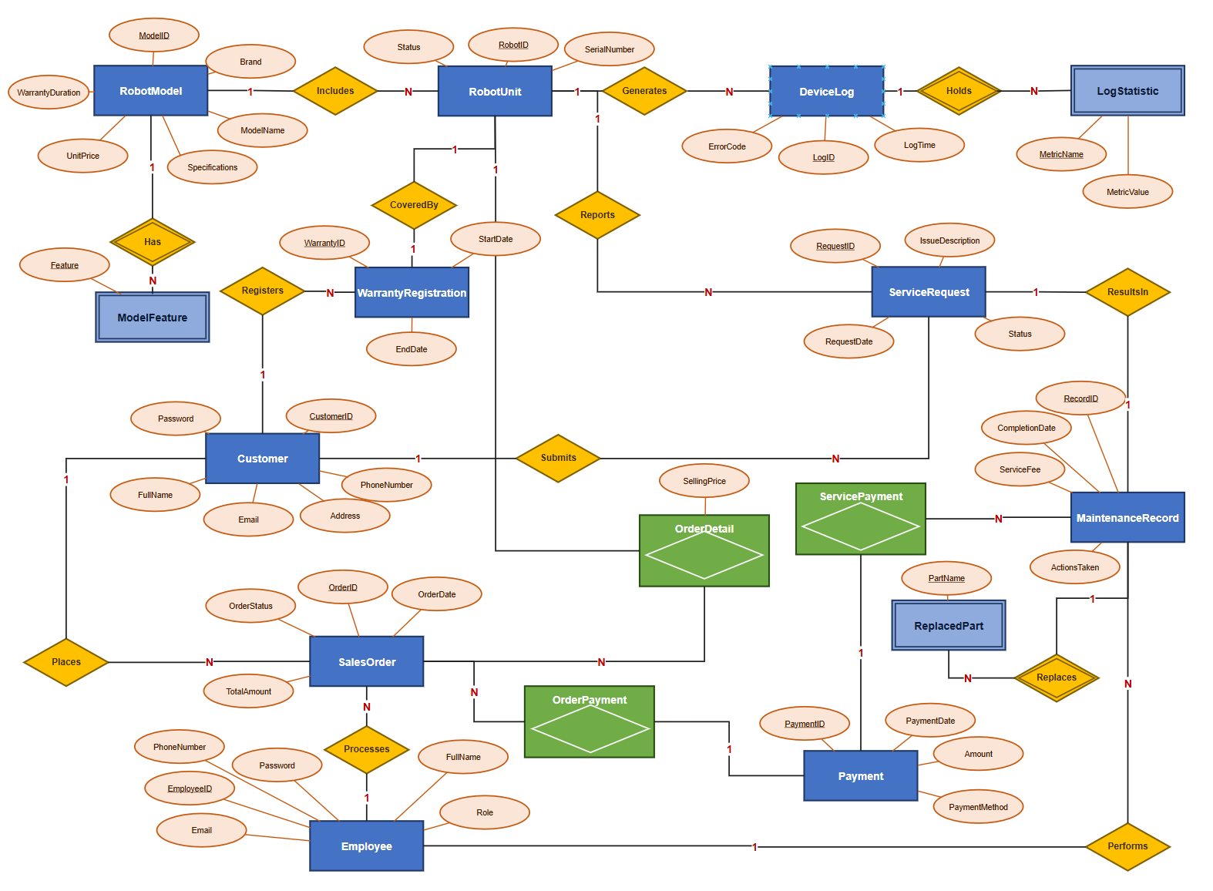
ER Diagram

2.1. Entities and Attributes
The following table summarizes all 16 entities identified for the system, organized by functional domain. Each entity is listed with its attributes and a brief description of its purpose within the system.
Entity | Attributes | Description
Customer | CustomerID (PK), FullName, PhoneNumber, Email, Address, Password | Stores customer personal information and account credentials
Employee | EmployeeID (PK), FullName, Role, PhoneNumber, Email, Password | Manages staff information including sales staff, technicians, and administrators
RobotModel | ModelID (PK), Brand, ModelName, Specifications, UnitPrice, WarrantyDuration | Defines robot product models with pricing and warranty info
ModelFeature | ModelID (PK, FK), Feature (PK) | Stores individual features for each robot model (multi-valued attribute decomposition)
RobotUnit | RobotID (PK), ModelID (FK), SerialNumber, Status | Tracks individual robot units in inventory
SalesOrder | OrderID (PK), CustomerID (FK), EmployeeID (FK), OrderDate, TotalAmount, OrderStatus | Records sales transactions
OrderDetail | RobotID (PK, FK), OrderID (FK), SellingPrice | Links specific robot units to sales orders
Payment | PaymentID (PK), Amount, PaymentDate, PaymentMethod | Records payment transactions (base entity)
OrderPayment | PaymentID (PK, FK), OrderID (FK) | Links payments to sales orders
ServicePayment | PaymentID (PK, FK), ServiceRecordID (FK) | Links payments to maintenance services
WarrantyRegistration | WarrantyID (PK), RobotID (FK), CustomerID (FK), StartDate, EndDate | Manages warranty coverage for purchased robots
ServiceRequest | RequestID (PK), RobotID (FK), CustomerID (FK), IssueDescription, RequestDate, Status | Tracks customer service/repair requests
MaintenanceRecord | RecordID (PK), RequestID (FK), TechnicianID (FK), ActionsTaken, ServiceFee, CompletionDate | Documents maintenance/repair work performed
ReplacedPart | RecordID (PK, FK), PartName (PK) | Tracks individual parts replaced during maintenance
DeviceLog | LogID (PK), RobotID (FK), LogTime, ErrorCode | Stores IoT data from connected robots
LogStatistic | LogID (PK, FK), MetricName (PK), MetricValue | Stores individual usage metrics from device logs

2.2. Relationships and Cardinalities
The following table documents all relationships between entities in the system, including the cardinality type and a description of each relationship.
Relationship | Type | Description
Customer → SalesOrder | 1:N | A customer can place multiple sales orders
Employee → SalesOrder | 1:N | An employee can process multiple sales orders
SalesOrder → OrderDetail | 1:N | A sales order contains multiple order detail lines
RobotUnit → OrderDetail | 1:1 | Each robot unit can only be sold once
RobotModel → RobotUnit | 1:N | A robot model can have multiple individual units
RobotModel → ModelFeature | 1:N | A robot model can have multiple features
Payment → OrderPayment | 1:1 | Each order payment links to exactly one payment
Payment → ServicePayment | 1:1 | Each service payment links to exactly one payment
SalesOrder → OrderPayment | 1:N | A sales order can have multiple payments
MaintenanceRecord → ServicePayment | 1:N | A maintenance record can have multiple payments
Customer → WarrantyRegistration | 1:N | A customer can have multiple warranty registrations
RobotUnit → WarrantyRegistration | 1:1 | Each robot unit has exactly one warranty
Customer → ServiceRequest | 1:N | A customer can submit multiple service requests
RobotUnit → ServiceRequest | 1:N | A robot unit can have multiple service requests
ServiceRequest → MaintenanceRecord | 1:1 | Each service request has one maintenance record
Employee → MaintenanceRecord | 1:N | A technician can handle multiple maintenance records
RobotUnit → DeviceLog | 1:N | A robot unit generates multiple device logs
DeviceLog → LogStatistic | 1:N | A device log contains multiple usage statistics
MaintenanceRecord → ReplacedPart | 1:N | A maintenance record can involve multiple replaced parts

3. Logical Model
This section converts the conceptual ERD into a relational schema. The logical model defines the structure of each relation, identifies primary keys and foreign keys, and resolves any M:N relationships. All relations are normalized to BCNF as established in Lab 3.

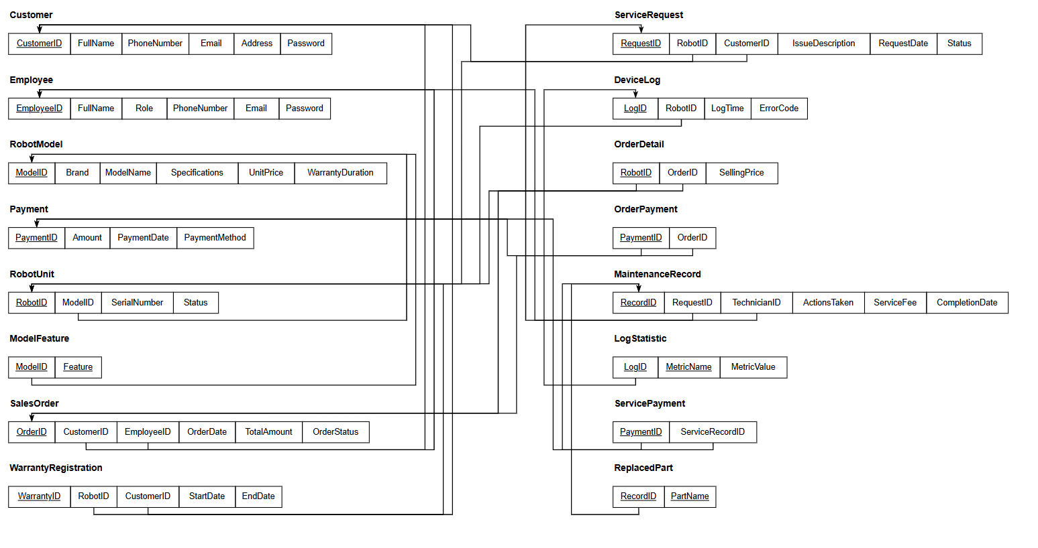
Relational Model Diagram

3.1. Relational Schema
The following presents the complete relational schema for the system, organized by functional domain. The schema consists of 16 relations, all normalized to BCNF (as established in Lab 3).
User Management
Customer(CustomerID, FullName, PhoneNumber, Email, Address, Password)
PK: CustomerID | Unique: Email, PhoneNumber
Employee(EmployeeID, FullName, Role, PhoneNumber, Email, Password)
PK: EmployeeID | Unique: Email
Product & Inventory
RobotModel(ModelID, Brand, ModelName, Specifications, UnitPrice, WarrantyDuration)
PK: ModelID | Unique: ModelName
ModelFeature(ModelID, Feature)
PK: {ModelID, Feature} | FK: ModelID → RobotModel
RobotUnit(RobotID, ModelID, SerialNumber, Status)
PK: RobotID | Unique: SerialNumber | FK: ModelID → RobotModel
Sales & Transactions
SalesOrder(OrderID, CustomerID, EmployeeID, OrderDate, TotalAmount, OrderStatus)
PK: OrderID | FK: CustomerID → Customer, EmployeeID → Employee
OrderDetail(RobotID, OrderID, SellingPrice)
PK: RobotID | FK: RobotID → RobotUnit, OrderID → SalesOrder
Payment(PaymentID, Amount, PaymentDate, PaymentMethod)
PK: PaymentID
OrderPayment(PaymentID, OrderID)
PK: PaymentID | FK: PaymentID → Payment, OrderID → SalesOrder
ServicePayment(PaymentID, ServiceRecordID)
PK: PaymentID | FK: PaymentID → Payment, ServiceRecordID → MaintenanceRecord
WarrantyRegistration(WarrantyID, RobotID, CustomerID, StartDate, EndDate)
PK: WarrantyID | Unique: RobotID | FK: RobotID → RobotUnit, CustomerID → Customer
Maintenance & IoT
ServiceRequest(RequestID, RobotID, CustomerID, IssueDescription, RequestDate, Status)
PK: RequestID | FK: RobotID → RobotUnit, CustomerID → Customer
MaintenanceRecord(RecordID, RequestID, TechnicianID, ActionsTaken, ServiceFee, CompletionDate)
PK: RecordID | Unique: RequestID | FK: RequestID → ServiceRequest, TechnicianID → Employee
ReplacedPart(RecordID, PartName)
PK: {RecordID, PartName} | FK: RecordID → MaintenanceRecord
DeviceLog(LogID, RobotID, LogTime, ErrorCode)
PK: LogID | Unique: {RobotID, LogTime} | FK: RobotID → RobotUnit
LogStatistic(LogID, MetricName, MetricValue)
PK: {LogID, MetricName} | FK: LogID → DeviceLog

3.2. Primary Keys and Foreign Keys
The following table provides a comprehensive summary of all primary keys, foreign keys, and unique keys across all 16 relations in the system.
Relation | Primary Key | Foreign Key(s) | Unique Key(s)
Customer | CustomerID | — | Email, PhoneNumber
Employee | EmployeeID | — | Email
RobotModel | ModelID | — | ModelName
ModelFeature | {ModelID, Feature} | ModelID → RobotModel | —
RobotUnit | RobotID | ModelID → RobotModel | SerialNumber
SalesOrder | OrderID | CustomerID → Customer, EmployeeID → Employee | —
OrderDetail | RobotID | RobotID → RobotUnit, OrderID → SalesOrder | —
Payment | PaymentID | — | —
OrderPayment | PaymentID | PaymentID → Payment, OrderID → SalesOrder | —
ServicePayment | PaymentID | PaymentID → Payment, ServiceRecordID → MaintenanceRecord | —
WarrantyRegistration | WarrantyID | RobotID → RobotUnit, CustomerID → Customer | RobotID
ServiceRequest | RequestID | RobotID → RobotUnit, CustomerID → Customer | —
MaintenanceRecord | RecordID | RequestID → ServiceRequest, TechnicianID → Employee | RequestID
ReplacedPart | {RecordID, PartName} | RecordID → MaintenanceRecord | —
DeviceLog | LogID | RobotID → RobotUnit | {RobotID, LogTime}
LogStatistic | {LogID, MetricName} | LogID → DeviceLog | —

3.3. M:N Relationship Resolution
In the original Lab 2 design, there were no explicit many-to-many (M:N) relationships. However, the conceptual model contained implicit multi-valued attributes which were resolved through decomposition during the normalization process in Lab 3. The following decompositions were performed:
- RobotModel.Features → ModelFeature (junction table): The multi-valued Features attribute was decomposed into a separate relation with a composite primary key {ModelID, Feature}.
- MaintenanceRecord.PartsReplaced → ReplacedPart (junction table): The multi-valued PartsReplaced attribute was decomposed into a separate relation with a composite primary key {RecordID, PartName}.
- DeviceLog.UsageStatistics → LogStatistic (junction table): The multi-valued UsageStatistics attribute was decomposed into a separate relation with a composite primary key {LogID, MetricName}.
Additionally, the Payment entity was decomposed into three relations — Payment, OrderPayment, and ServicePayment — using a supertype/subtype pattern. This eliminates nullable foreign keys (OrderID and ServiceRecordID) that would have existed in a single Payment table, as each payment is either for an order or for a service, but not both.

4. Physical Model
This section maps the logical schema to a physical database design for Microsoft SQL Server. It includes detailed table definitions with specific data types, identity columns, default values, and storage considerations appropriate for a production environment.

4.1. Table Definitions with Data Types
The following tables define the complete physical schema for all 16 relations. Each table specifies column names, SQL Server data types, nullability, keys, default values, and descriptions.
Table 1: Customer
Column | Data Type | Nullable | Key | Default | Description
CustomerID | INT | NO | PK (IDENTITY) | Auto-increment | Unique customer identifier
FullName | NVARCHAR(100) | NO |  |  | Customer full name
PhoneNumber | VARCHAR(15) | NO | UNIQUE |  | Contact phone number
Email | NVARCHAR(100) | NO | UNIQUE |  | Email address
Address | NVARCHAR(255) | YES |  | NULL | Residential address
Password | NVARCHAR(255) | NO |  |  | Hashed account password
Table 2: Employee
Column | Data Type | Nullable | Key | Default | Description
EmployeeID | INT | NO | PK (IDENTITY) | Auto-increment | Unique employee identifier
FullName | NVARCHAR(100) | NO |  |  | Employee full name
Role | NVARCHAR(50) | NO |  |  | Job role (Sales Staff/Technician/Administrator)
PhoneNumber | VARCHAR(15) | NO |  |  | Contact phone number
Email | NVARCHAR(100) | NO | UNIQUE |  | Email address
Password | NVARCHAR(255) | NO |  |  | Hashed account password
Table 3: RobotModel
Column | Data Type | Nullable | Key | Default | Description
ModelID | INT | NO | PK (IDENTITY) | Auto-increment | Unique model identifier
Brand | NVARCHAR(100) | NO |  |  | Manufacturer brand name
ModelName | NVARCHAR(100) | NO | UNIQUE |  | Model designation
Specifications | NVARCHAR(MAX) | YES |  | NULL | Technical specifications
UnitPrice | DECIMAL(18,2) | NO |  |  | Retail price per unit
WarrantyDuration | INT | NO |  |  | Warranty period in months
Table 4: ModelFeature
Column | Data Type | Nullable | Key | Default | Description
ModelID | INT | NO | PK, FK → RobotModel |  | Reference to robot model
Feature | NVARCHAR(100) | NO | PK |  | Individual feature name
Table 5: RobotUnit
Column | Data Type | Nullable | Key | Default | Description
RobotID | INT | NO | PK (IDENTITY) | Auto-increment | Unique robot unit identifier
ModelID | INT | NO | FK → RobotModel |  | Reference to robot model
SerialNumber | VARCHAR(50) | NO | UNIQUE |  | Manufacturer serial number
Status | NVARCHAR(30) | NO |  | 'Available' | Current unit status
Table 6: SalesOrder
Column | Data Type | Nullable | Key | Default | Description
OrderID | INT | NO | PK (IDENTITY) | Auto-increment | Unique order identifier
CustomerID | INT | NO | FK → Customer |  | Purchasing customer
EmployeeID | INT | NO | FK → Employee |  | Processing staff member
OrderDate | DATETIME | NO |  | GETDATE() | Date/time order was placed
TotalAmount | DECIMAL(18,2) | NO |  |  | Total order value
OrderStatus | NVARCHAR(30) | NO |  | 'Pending' | Current order status
Table 7: OrderDetail
Column | Data Type | Nullable | Key | Default | Description
RobotID | INT | NO | PK, FK → RobotUnit |  | Sold robot unit
OrderID | INT | NO | FK → SalesOrder |  | Associated sales order
SellingPrice | DECIMAL(18,2) | NO |  |  | Actual selling price
Table 8: Payment
Column | Data Type | Nullable | Key | Default | Description
PaymentID | INT | NO | PK (IDENTITY) | Auto-increment | Unique payment identifier
Amount | DECIMAL(18,2) | NO |  |  | Payment amount
PaymentDate | DATETIME | NO |  | GETDATE() | Date/time of payment
PaymentMethod | NVARCHAR(30) | NO |  |  | Method of payment
Table 9: OrderPayment
Column | Data Type | Nullable | Key | Default | Description
PaymentID | INT | NO | PK, FK → Payment |  | Reference to payment
OrderID | INT | NO | FK → SalesOrder |  | Reference to sales order
Table 10: ServicePayment
Column | Data Type | Nullable | Key | Default | Description
PaymentID | INT | NO | PK, FK → Payment |  | Reference to payment
ServiceRecordID | INT | NO | FK → MaintenanceRecord |  | Reference to maintenance record
Table 11: WarrantyRegistration
Column | Data Type | Nullable | Key | Default | Description
WarrantyID | INT | NO | PK (IDENTITY) | Auto-increment | Unique warranty identifier
RobotID | INT | NO | FK → RobotUnit, UNIQUE |  | Registered robot unit
CustomerID | INT | NO | FK → Customer |  | Warranty holder
StartDate | DATE | NO |  |  | Warranty start date
EndDate | DATE | NO |  |  | Warranty expiration date
Table 12: ServiceRequest
Column | Data Type | Nullable | Key | Default | Description
RequestID | INT | NO | PK (IDENTITY) | Auto-increment | Unique request identifier
RobotID | INT | NO | FK → RobotUnit |  | Robot requiring service
CustomerID | INT | NO | FK → Customer |  | Requesting customer
IssueDescription | NVARCHAR(MAX) | NO |  |  | Description of the issue
RequestDate | DATETIME | NO |  | GETDATE() | Date/time request was submitted
Status | NVARCHAR(30) | NO |  | 'Pending' | Current request status
Table 13: MaintenanceRecord
Column | Data Type | Nullable | Key | Default | Description
RecordID | INT | NO | PK (IDENTITY) | Auto-increment | Unique record identifier
RequestID | INT | NO | FK → ServiceRequest, UNIQUE |  | Associated service request
TechnicianID | INT | NO | FK → Employee |  | Assigned technician
ActionsTaken | NVARCHAR(MAX) | YES |  | NULL | Description of repair actions
ServiceFee | DECIMAL(18,2) | NO |  | 0 | Service charge amount
CompletionDate | DATETIME | YES |  | NULL | Date/time of completion
Table 14: ReplacedPart
Column | Data Type | Nullable | Key | Default | Description
RecordID | INT | NO | PK, FK → MaintenanceRecord |  | Reference to maintenance record
PartName | NVARCHAR(100) | NO | PK |  | Name of replaced part
Table 15: DeviceLog
Column | Data Type | Nullable | Key | Default | Description
LogID | INT | NO | PK (IDENTITY) | Auto-increment | Unique log identifier
RobotID | INT | NO | FK → RobotUnit |  | Source robot unit
LogTime | DATETIME | NO |  | GETDATE() | Timestamp of log entry
ErrorCode | VARCHAR(20) | YES |  | NULL | Error code (if any)
Table 16: LogStatistic
Column | Data Type | Nullable | Key | Default | Description
LogID | INT | NO | PK, FK → DeviceLog |  | Reference to device log
MetricName | NVARCHAR(100) | NO | PK |  | Name of usage metric
MetricValue | NVARCHAR(255) | YES |  | NULL | Value of the metric

5. Constraints
This section provides a comprehensive description of all constraints applied to the database schema. Constraints ensure data integrity, consistency, and reliability by enforcing business rules at the database level. The constraints are organized into column-level and table-level categories.

5.1. Column-Level Constraints
NOT NULL Constraints
NOT NULL constraints are applied to all mandatory columns to prevent incomplete records. The following table highlights key NOT NULL columns across the schema. All primary key columns and most business-critical columns are defined as NOT NULL.
Table | NOT NULL Columns | Purpose
Customer | FullName, PhoneNumber, Email, Password | Essential customer information
Employee | FullName, Role, PhoneNumber, Email, Password | Essential employee information
RobotModel | Brand, ModelName, UnitPrice, WarrantyDuration | Core product information
RobotUnit | ModelID, SerialNumber, Status | Inventory tracking fields
SalesOrder | CustomerID, EmployeeID, OrderDate, TotalAmount, OrderStatus | Transaction details
OrderDetail | OrderID, SellingPrice | Order line item details
Payment | Amount, PaymentDate, PaymentMethod | Payment transaction details
ServiceRequest | RobotID, CustomerID, IssueDescription, RequestDate, Status | Service request details
MaintenanceRecord | RequestID, TechnicianID, ServiceFee | Maintenance record details
WarrantyRegistration | RobotID, CustomerID, StartDate, EndDate | Warranty coverage details
UNIQUE Constraints
UNIQUE constraints prevent duplicate values in columns that must contain distinct data. These are applied in addition to the uniqueness guaranteed by primary keys.
Table | Column(s) | Purpose
Customer | Email | Prevent duplicate email addresses
Customer | PhoneNumber | Prevent duplicate phone numbers
Employee | Email | Prevent duplicate employee emails
RobotModel | ModelName | Ensure unique model names
RobotUnit | SerialNumber | Ensure unique serial numbers
WarrantyRegistration | RobotID | Each robot has at most one active warranty
MaintenanceRecord | RequestID | Each service request has at most one maintenance record
DEFAULT Values
DEFAULT constraints provide automatic values for columns when no explicit value is supplied during insertion. These improve usability and reduce the risk of insertion errors.
Table | Column | Default Value | Purpose
RobotUnit | Status | 'Available' | New units default to available
SalesOrder | OrderDate | GETDATE() | Auto-set order timestamp
SalesOrder | OrderStatus | 'Pending' | New orders start as pending
Payment | PaymentDate | GETDATE() | Auto-set payment timestamp
ServiceRequest | RequestDate | GETDATE() | Auto-set request timestamp
ServiceRequest | Status | 'Pending' | New requests start as pending
MaintenanceRecord | ServiceFee | 0 | Default no charge (warranty coverage)
CHECK Constraints
CHECK constraints enforce domain-specific validation rules at the database level, ensuring that column values fall within acceptable ranges or match predefined lists.
Table | Column | CHECK Expression | Purpose
Employee | Role | IN ('Sales Staff', 'Technician', 'Administrator') | Restrict valid roles
RobotModel | UnitPrice | > 0 | Price must be positive
RobotModel | WarrantyDuration | > 0 | Duration must be positive
RobotUnit | Status | IN ('Available', 'Sold', 'Under Maintenance', 'Retired') | Valid statuses only
SalesOrder | TotalAmount | >= 0 | Non-negative order total
SalesOrder | OrderStatus | IN ('Pending', 'Confirmed', 'Shipped', 'Delivered', 'Cancelled') | Valid statuses
OrderDetail | SellingPrice | > 0 | Price must be positive
Payment | Amount | > 0 | Payment must be positive
Payment | PaymentMethod | IN ('Cash', 'Credit Card', 'Bank Transfer', 'E-Wallet') | Valid methods
WarrantyRegistration | EndDate | EndDate > StartDate | End must be after start
ServiceRequest | Status | IN ('Pending', 'Assigned', 'In Progress', 'Completed', 'Cancelled') | Valid statuses
MaintenanceRecord | ServiceFee | >= 0 | Non-negative fee

5.2. Table-Level Constraints
PRIMARY KEY Constraints
Every table has a primary key constraint that uniquely identifies each row. The following table lists all primary key definitions, including whether they use IDENTITY auto-increment or are composite keys.
Table | Primary Key Column(s) | Type
Customer | CustomerID | IDENTITY (1,1)
Employee | EmployeeID | IDENTITY (1,1)
RobotModel | ModelID | IDENTITY (1,1)
ModelFeature | {ModelID, Feature} | Composite
RobotUnit | RobotID | IDENTITY (1,1)
SalesOrder | OrderID | IDENTITY (1,1)
OrderDetail | RobotID | Single column (no IDENTITY)
Payment | PaymentID | IDENTITY (1,1)
OrderPayment | PaymentID | Single column (no IDENTITY)
ServicePayment | PaymentID | Single column (no IDENTITY)
WarrantyRegistration | WarrantyID | IDENTITY (1,1)
ServiceRequest | RequestID | IDENTITY (1,1)
MaintenanceRecord | RecordID | IDENTITY (1,1)
ReplacedPart | {RecordID, PartName} | Composite
DeviceLog | LogID | IDENTITY (1,1)
LogStatistic | {LogID, MetricName} | Composite
FOREIGN KEY Constraints
Foreign key constraints maintain referential integrity between related tables. The following table lists all foreign key relationships with their referential actions (ON DELETE and ON UPDATE).
Table | FK Column | References | ON DELETE | ON UPDATE
ModelFeature | ModelID | RobotModel.ModelID | CASCADE | CASCADE
RobotUnit | ModelID | RobotModel.ModelID | NO ACTION | CASCADE
SalesOrder | CustomerID | Customer.CustomerID | NO ACTION | CASCADE
SalesOrder | EmployeeID | Employee.EmployeeID | NO ACTION | CASCADE
OrderDetail | RobotID | RobotUnit.RobotID | NO ACTION | NO ACTION
OrderDetail | OrderID | SalesOrder.OrderID | CASCADE | CASCADE
OrderPayment | PaymentID | Payment.PaymentID | CASCADE | CASCADE
OrderPayment | OrderID | SalesOrder.OrderID | NO ACTION | NO ACTION
ServicePayment | PaymentID | Payment.PaymentID | CASCADE | CASCADE
ServicePayment | ServiceRecordID | MaintenanceRecord.RecordID | NO ACTION | NO ACTION
WarrantyRegistration | RobotID | RobotUnit.RobotID | NO ACTION | CASCADE
WarrantyRegistration | CustomerID | Customer.CustomerID | NO ACTION | CASCADE
ServiceRequest | RobotID | RobotUnit.RobotID | NO ACTION | CASCADE
ServiceRequest | CustomerID | Customer.CustomerID | NO ACTION | CASCADE
MaintenanceRecord | RequestID | ServiceRequest.RequestID | NO ACTION | CASCADE
MaintenanceRecord | TechnicianID | Employee.EmployeeID | NO ACTION | CASCADE
ReplacedPart | RecordID | MaintenanceRecord.RecordID | CASCADE | CASCADE
DeviceLog | RobotID | RobotUnit.RobotID | NO ACTION | CASCADE
LogStatistic | LogID | DeviceLog.LogID | CASCADE | CASCADE
Composite Unique Constraints
Composite unique constraints ensure that combinations of column values are unique, preventing logical duplicate records.
Table | Columns | Purpose
DeviceLog | {RobotID, LogTime} | Prevent duplicate logs for same robot at same time

6. Conclusion and Reflection
This lab successfully designed a complete relational database for the Household Cleaning Robot Sales & Maintenance Management System through three structured design phases: conceptual modeling (Entity-Relationship Diagram), logical design (relational schema with primary and foreign keys), and physical implementation (SQL Server table definitions with specific data types and constraints). The design builds upon the requirements analysis from Lab 1, the ERD from Lab 2, and the normalization work from Lab 3.
Key Accomplishments:
- Identified 16 entities capturing all aspects of the business domain — from customer management and product inventory to sales transactions, warranty tracking, maintenance services, and IoT device monitoring
- Established 19 relationships with proper cardinalities (1:1, 1:N) ensuring accurate representation of business rules
- Defined comprehensive data types optimized for Microsoft SQL Server, including appropriate use of NVARCHAR for Unicode support, DECIMAL for financial precision, and IDENTITY for auto-increment primary keys
- Specified 40+ constraints ensuring data integrity at multiple levels — including NOT NULL, UNIQUE, CHECK, DEFAULT, PRIMARY KEY, and FOREIGN KEY constraints
Reflection on Constraints:
The constraints defined in this lab serve as the primary mechanism for enforcing data integrity at the database level. Each type of constraint addresses a specific aspect of data quality:
- NOT NULL constraints prevent incomplete records by requiring values for all essential fields, ensuring that critical business data is always captured
- UNIQUE constraints eliminate duplicate data in columns such as Email, PhoneNumber, SerialNumber, and ModelName, maintaining data distinctness
- CHECK constraints enforce business rules directly at the database level — for example, ensuring prices are positive, dates are logically ordered, and status values conform to predefined enumerations
- FOREIGN KEY constraints maintain referential integrity between related tables, with appropriate ON DELETE and ON UPDATE actions (CASCADE for dependent child records, NO ACTION for important references that should not be implicitly removed)
- DEFAULT values improve usability by automatically populating timestamps (GETDATE()), initial statuses ('Pending', 'Available'), and zero-value fees, reducing the burden on application code and minimizing insertion errors
The combination of these constraints creates a robust, self-documenting database that enforces business rules independently of the application layer, providing a defense-in-depth approach to data integrity.
Finally, the normalization work completed in Lab 3 (achieving BCNF for all relations) ensures minimal redundancy and eliminates update anomalies. The constraints defined in Lab 4 add an additional layer of protection by enforcing domain rules, referential integrity, and business logic directly within the database schema. Together, normalization and constraints create a database design that is both structurally sound and operationally reliable for the Household Cleaning Robot Sales & Maintenance Management System.

V. Lab 5 - SQL Queries, View, Index, Functions, Procedures, and Triggers

1. Objective
Lab 5 focuses on practicing SQL programming on the database designed in Lab 4 for the Household Cleaning Robot Sales & Maintenance Management System (HCRS&MMS). Students write queries ranging from basic to advanced, and build Functions, Stored Procedures, and Triggers to enforce business rules and automate tasks, together with Views and Indexes.
Specific objectives:
- Write SELECT, WHERE, ORDER BY queries and aggregate functions (COUNT/SUM/AVG/MAX/MIN).
- Write intermediate queries: multi-table JOINs, GROUP BY/HAVING and subqueries.
- Write advanced queries: nested subqueries, EXISTS/IN/ANY/ALL, and set operations UNION/INTERSECT/EXCEPT.
- Build at least 4 Functions, 4 Stored Procedures and 4 Triggers.
- Create Views to simplify queries and Indexes to improve performance.

2. Database Design (from Lab 4)
The HCRS_DB database consists of 16 relations (normalized to BCNF in Lab 4) covering the main business areas: user management, product & inventory, sales & payment, warranty, maintenance, and IoT data. The table below summarizes the main entities; the full DDL (data types, PK/FK/UNIQUE/CHECK/DEFAULT).
Relation | Key Attributes | Meaning
Customer | CustomerID (PK), FullName, PhoneNumber, Email, Address, Password | Customers
Employee | EmployeeID (PK), FullName, Role, PhoneNumber, Email, Password | Employees (sales / technical / admin)
RobotModel | ModelID (PK), Brand, ModelName, Specifications, UnitPrice, WarrantyDuration | Robot models (catalog)
ModelFeature | ModelID (PK,FK), Feature (PK) | Features of each robot model
RobotUnit | RobotID (PK), ModelID (FK), SerialNumber, Status | Individual robot units in stock
SalesOrder | OrderID (PK), CustomerID (FK), EmployeeID (FK), OrderDate, TotalAmount, OrderStatus | Sales orders
OrderDetail | RobotID (PK,FK), OrderID (FK), SellingPrice | Order line items
Payment | PaymentID (PK), Amount, PaymentDate, PaymentMethod | Payments (super-type)
OrderPayment | PaymentID (PK,FK), OrderID (FK) | Payments for sales orders
ServicePayment | PaymentID (PK,FK), ServiceRecordID (FK) | Payments for maintenance services
WarrantyRegistration | WarrantyID (PK), RobotID (FK,UQ), CustomerID (FK), StartDate, EndDate | Warranty registrations
ServiceRequest | RequestID (PK), RobotID (FK), CustomerID (FK), IssueDescription, RequestDate, Status | Service / repair requests
MaintenanceRecord | RecordID (PK), RequestID (FK,UQ), TechnicianID (FK), ActionsTaken, ServiceFee, CompletionDate | Maintenance results
ReplacedPart | RecordID (PK,FK), PartName (PK) | Replaced parts
DeviceLog | LogID (PK), RobotID (FK), LogTime, ErrorCode | IoT data from robots
LogStatistic | LogID (PK,FK), MetricName (PK), MetricValue | Metrics derived from logs
In addition to the 16 tables above, Lab 5 adds a supporting table RobotStatusAudit to record the history of robot status changes (written automatically by a trigger).
Sample data: 8 customers, 8 employees, 6 robot models, 15 robots, 8 sales orders, 8 payments, 8 warranty registrations, 7 service requests, 6 maintenance records and 10 IoT log records - enough for every query to return meaningful results.

3. SQL Queries
This section presents SQL queries at three increasing levels: basic, intermediate and advanced. Each query includes an explanation and a placeholder for the execution result screenshot.

3.1. Basic Queries

SELECT queries over entire tables
1. Get all customers
Retrieve all records from the Customer table.
SELECT * FROM Customer;
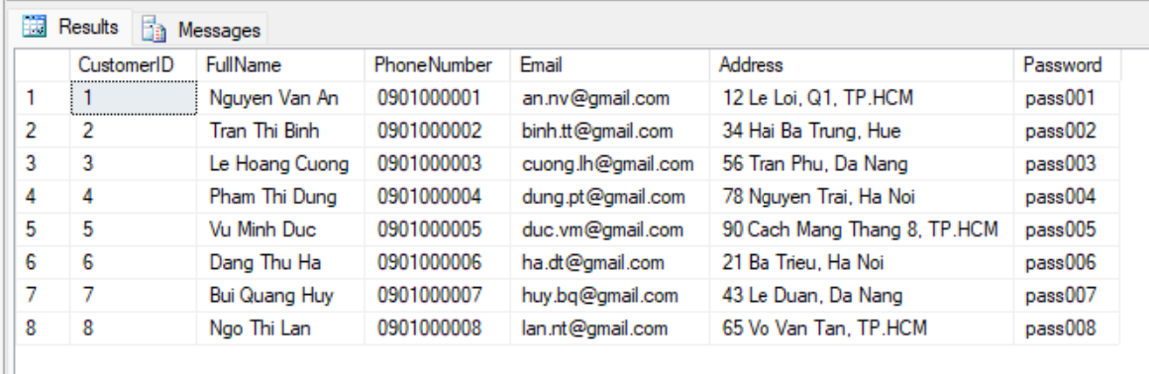2. Get all employees
Retrieve all employees (sales, technical, admin).
SELECT * FROM Employee;
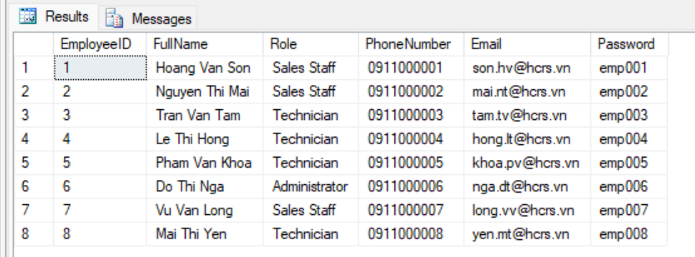3. Get all robot models in the catalog
Retrieve all robot models with selling price and warranty duration.
SELECT * FROM RobotModel;
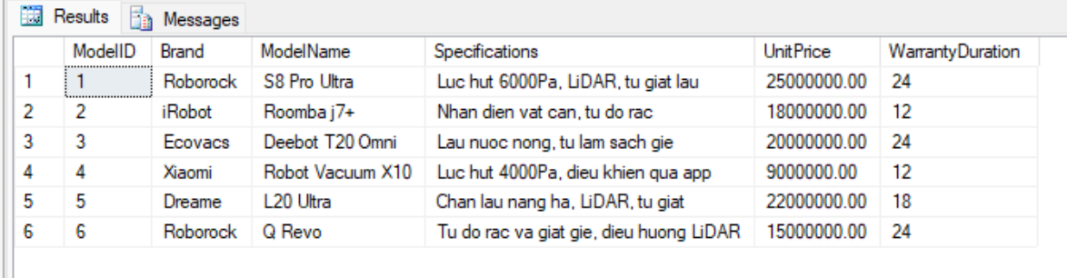4. Get all robots in stock
Retrieve every robot unit and its current status.
SELECT * FROM RobotUnit;
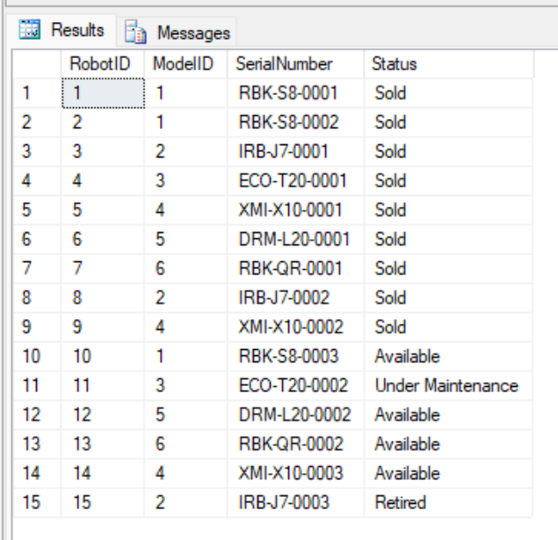
5. Get all sales orders
Retrieve all sales orders.
SELECT * FROM SalesOrder;
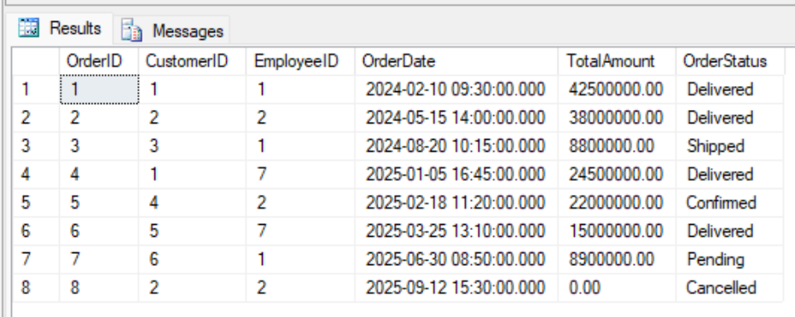
6. Get data from transaction and maintenance tables
Quick look at the remaining tables: payments, service requests, maintenance, IoT logs.
SELECT * FROM Payment;
SELECT * FROM ServiceRequest;
SELECT * FROM MaintenanceRecord;
SELECT * FROM DeviceLog;
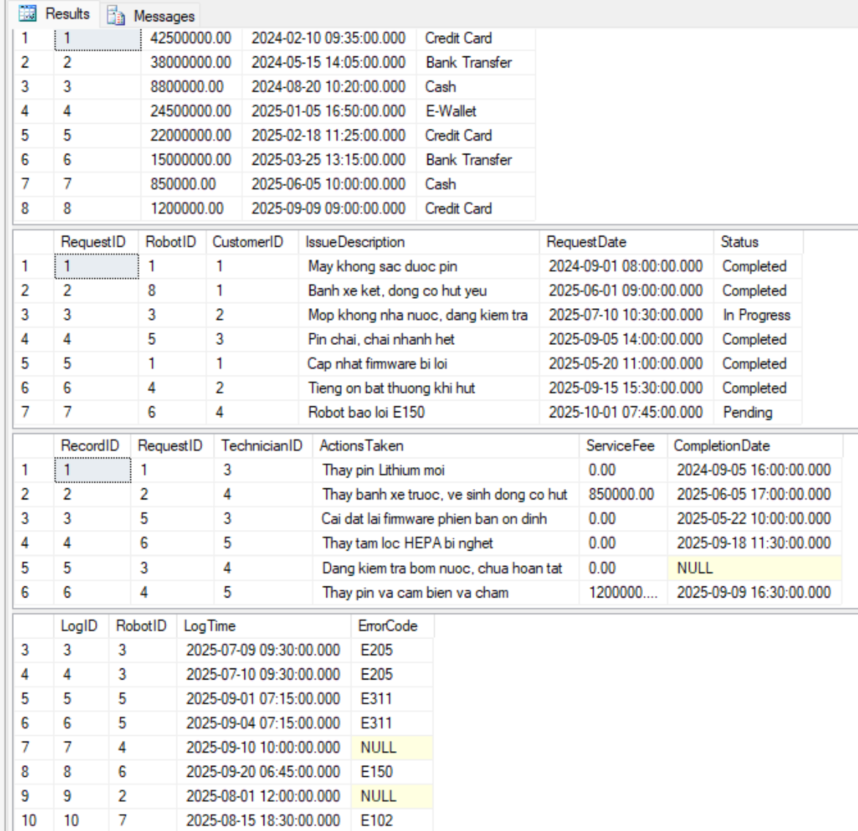

Filtering data with WHERE
1. Customers in Ho Chi Minh City
Filter customers whose address contains "TP.HCM" using the LIKE operator.
SELECT CustomerID, FullName, Address
FROM Customer
WHERE Address LIKE N'%TP.HCM%';
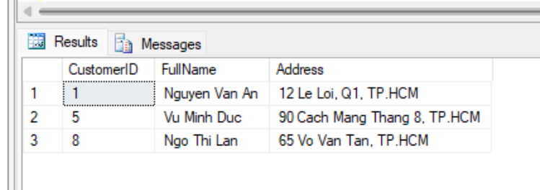
2. Employees who are technicians
Filter employees whose Role is Technician.
SELECT EmployeeID, FullName, Role
FROM Employee
WHERE Role = N'Technician';
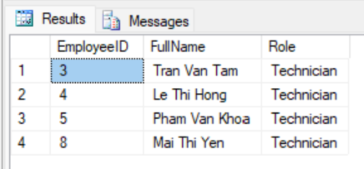
3. Robot models priced above 20 million
Filter premium robot models with UnitPrice > 20,000,000 VND.
SELECT ModelID, Brand, ModelName, UnitPrice
FROM RobotModel
WHERE UnitPrice > 20000000;
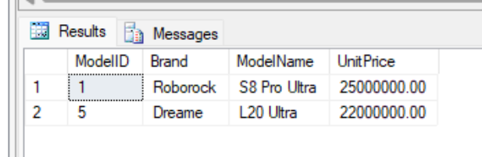
4. Robot models of the Roborock brand
Filter robot models belonging to the Roborock brand.
SELECT ModelID, ModelName, UnitPrice
FROM RobotModel
WHERE Brand = N'Roborock';
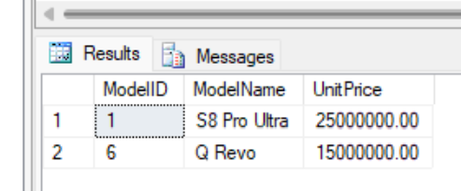
5. Robots still available in stock
Filter robots with status Available (ready to sell).
SELECT RobotID, ModelID, SerialNumber
FROM RobotUnit
WHERE Status = N'Available';
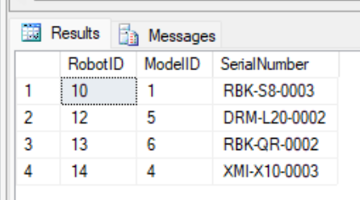
6. Successfully delivered orders
Filter orders with status Delivered.
SELECT OrderID, CustomerID, OrderDate, TotalAmount
FROM SalesOrder
WHERE OrderStatus = N'Delivered';
[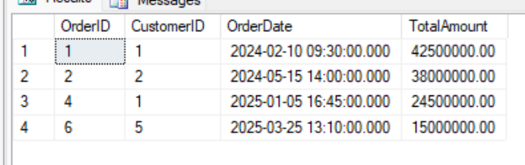
7. Orders in 2025
Filter orders created in 2025 using a date-range condition.
SELECT OrderID, OrderDate, TotalAmount, OrderStatus
FROM SalesOrder
WHERE OrderDate >= '2025-01-01' AND OrderDate < '2026-01-01';
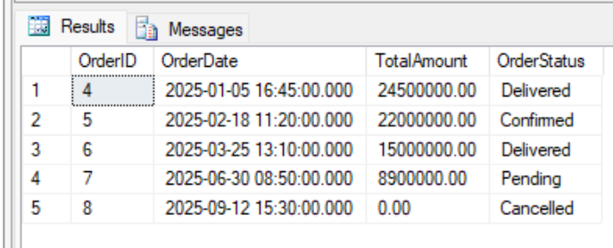
8. Orders with total amount from 10 to 40 million
Filter orders by value range using BETWEEN.
SELECT OrderID, TotalAmount, OrderStatus
FROM SalesOrder
WHERE TotalAmount BETWEEN 10000000 AND 40000000;
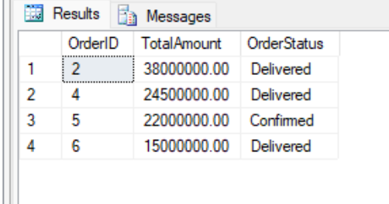
9. Payments by credit card
Filter payment transactions made by Credit Card.
SELECT PaymentID, Amount, PaymentDate
FROM Payment
WHERE PaymentMethod = N'Credit Card';
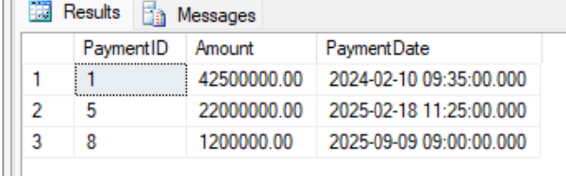
10. Service requests not yet completed
Filter service requests not in Completed status (using IN for multiple statuses).
SELECT RequestID, RobotID, Status, RequestDate
FROM ServiceRequest
WHERE Status IN (N'Pending', N'Assigned', N'In Progress');
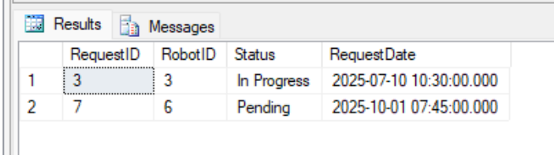
11. Warranties still valid
Filter warranty registrations whose end date has not passed the current date.
SELECT WarrantyID, RobotID, StartDate, EndDate
FROM WarrantyRegistration
WHERE EndDate >= CAST(GETDATE() AS DATE);
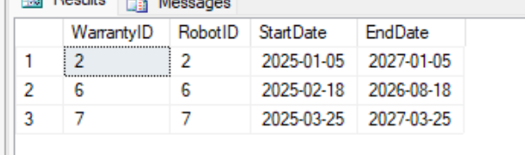
12. Device logs with an error code
Filter IoT logs that actually recorded an error code (ErrorCode IS NOT NULL).
SELECT LogID, RobotID, LogTime, ErrorCode
FROM DeviceLog
WHERE ErrorCode IS NOT NULL;
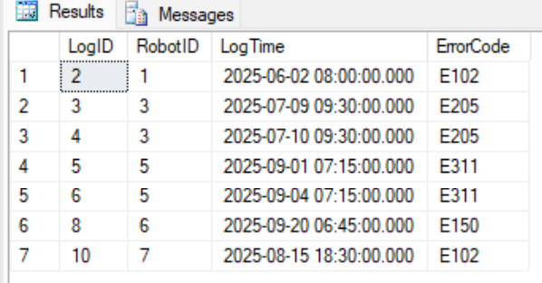
13. Maintenance with a service fee
Filter maintenance records that actually incurred a service fee (> 0).
SELECT RecordID, RequestID, ServiceFee, CompletionDate
FROM MaintenanceRecord
WHERE ServiceFee > 0;
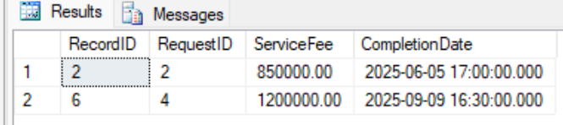

Sorting with ORDER BY
1. Robot models by descending price
Sort the catalog from most to least expensive.
SELECT ModelID, ModelName, UnitPrice
FROM RobotModel
ORDER BY UnitPrice DESC;
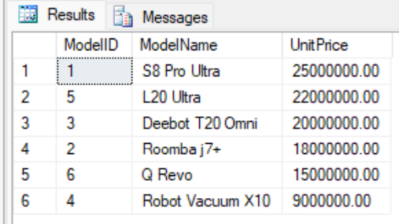
2. Customers by name A-Z
Sort the customer list by full name ascending.
SELECT CustomerID, FullName
FROM Customer
ORDER BY FullName ASC;
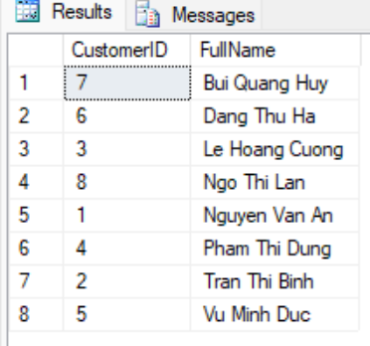
3. Q1/2025 orders by descending date
List orders in Q1 2025, sorted by order date descending.
SELECT OrderID, OrderDate, TotalAmount
FROM SalesOrder
WHERE OrderDate >= '2025-01-01' AND OrderDate < '2025-04-01'
ORDER BY OrderDate DESC;
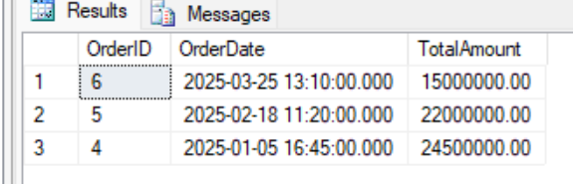
4. Employees by role then by name
Sort employees by Role, and by name within the same role.
SELECT FullName, Role
FROM Employee
ORDER BY Role ASC, FullName ASC;
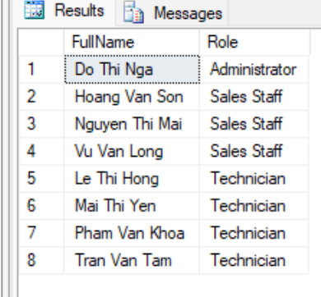
5. Robots by status then by model
Sort robots by Status, and by ModelID within the same status.
SELECT RobotID, ModelID, Status
FROM RobotUnit
ORDER BY Status ASC, ModelID ASC;
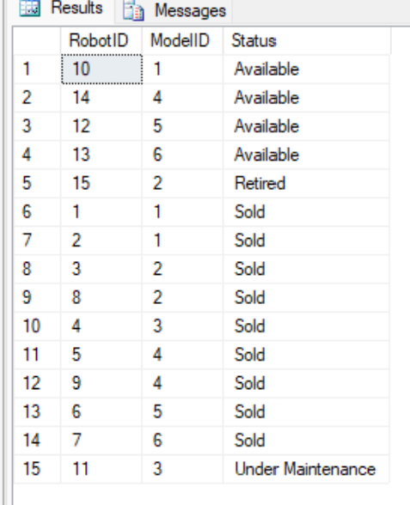
6. Payments by descending amount
Sort transactions by amount from high to low.
SELECT PaymentID, Amount, PaymentMethod
FROM Payment
ORDER BY Amount DESC;
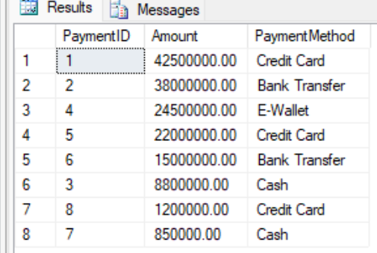
7. Service requests by ascending date
Sort service requests by submission date ascending.
SELECT RequestID, RobotID, RequestDate, Status
FROM ServiceRequest
ORDER BY RequestDate ASC;
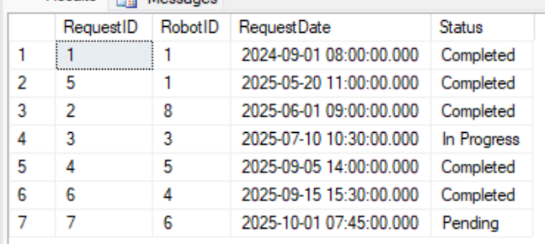
8. Maintenance by descending fee
Sort maintenance records by service fee descending.
SELECT RecordID, RequestID, ServiceFee
FROM MaintenanceRecord
ORDER BY ServiceFee DESC;
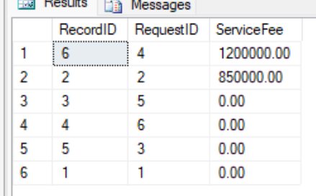
9. Warranties by expiry date
Sort warranty registrations by end date ascending.
SELECT WarrantyID, RobotID, EndDate
FROM WarrantyRegistration
ORDER BY EndDate ASC;
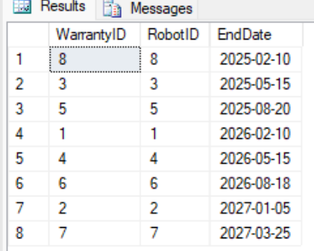
10. Latest device logs first
Sort IoT logs by time descending (latest first).
SELECT LogID, RobotID, LogTime, ErrorCode
FROM DeviceLog
ORDER BY LogTime DESC;
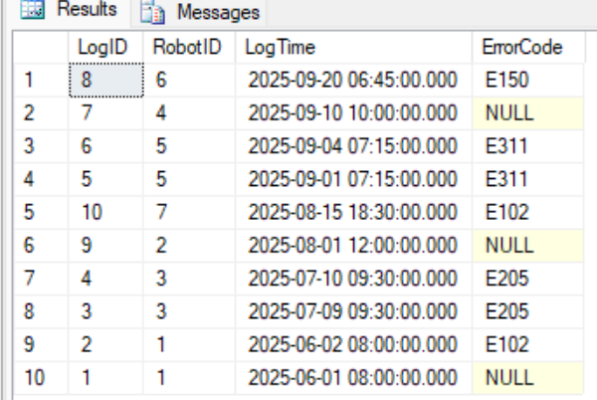

Aggregate functions (COUNT, SUM, AVG, MAX, MIN)
1. Total number of customers
Count the total number of customers in the system.
SELECT COUNT(*) AS TotalCustomers FROM Customer;
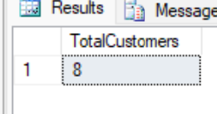
2. Total number of robots in stock
Count the total number of robot units managed.
SELECT COUNT(*) AS TotalRobots FROM RobotUnit;
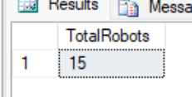
3. Average robot model price
Compute the average selling price of robot models.
SELECT AVG(UnitPrice) AS AvgPrice FROM RobotModel;
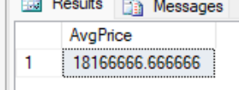
4. Highest and lowest price
Find the highest and lowest selling price in the catalog.
SELECT MAX(UnitPrice) AS MaxPrice, MIN(UnitPrice) AS MinPrice FROM RobotModel;
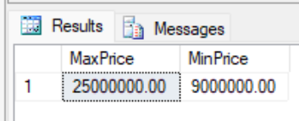
5. Total revenue by orders
Compute the total value of all orders (by the TotalAmount column).
SELECT SUM(TotalAmount) AS TotalRevenue FROM SalesOrder;
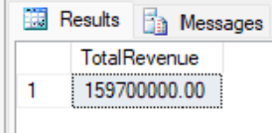
6. Number of robots ready to sell
Count robots currently in Available status.
SELECT COUNT(*) AS AvailableRobots
FROM RobotUnit
WHERE Status = N'Available';
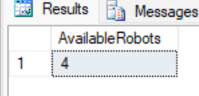
7. Total amount actually collected from payments
Compute the total amount collected across all payment transactions.
SELECT SUM(Amount) AS TotalCollected FROM Payment;
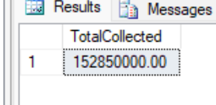
8. Average service fee
Compute the average maintenance fee across records.
SELECT AVG(ServiceFee) AS AvgServiceFee FROM MaintenanceRecord;
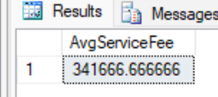
9. Highest service fee
Find the highest maintenance fee ever incurred.
SELECT MAX(ServiceFee) AS MaxServiceFee FROM MaintenanceRecord;
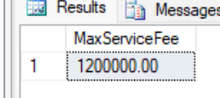
10. Total number of service requests
Count the total number of maintenance/repair requests.
SELECT COUNT(*) AS TotalRequests FROM ServiceRequest;
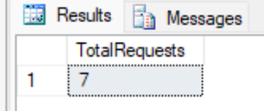
11. Number of logs recording an error
Count IoT logs that have an error code (ignoring NULL logs).
SELECT COUNT(ErrorCode) AS ErrorLogCount FROM DeviceLog;
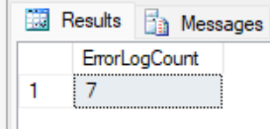

3.2. Intermediate Queries

Joining multiple tables (INNER JOIN / LEFT JOIN)
1. Orders with customer and salesperson names
INNER JOIN the three tables SalesOrder, Customer, Employee to display the customer and the handling employee.
SELECT so.OrderID, c.FullName AS Customer, e.FullName AS SalesStaff,
so.OrderDate, so.TotalAmount, so.OrderStatus
FROM SalesOrder so
JOIN Customer c ON so.CustomerID = c.CustomerID
JOIN Employee e ON so.EmployeeID = e.EmployeeID;
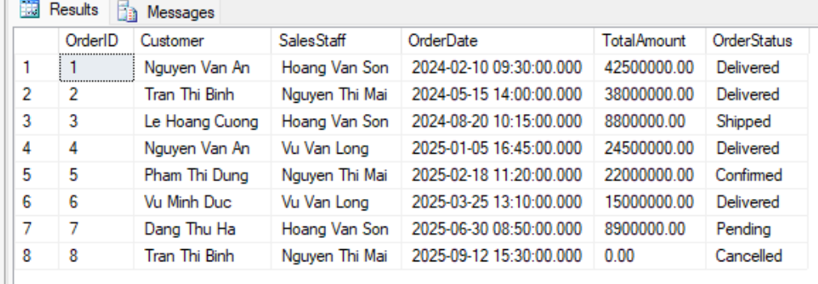
2. Sold robots with model and selling price
JOIN OrderDetail -> RobotUnit -> RobotModel to know which model each sold robot belongs to.
SELECT od.OrderID, od.RobotID, rm.Brand, rm.ModelName, od.SellingPrice
FROM OrderDetail od
JOIN RobotUnit ru ON od.RobotID = ru.RobotID
JOIN RobotModel rm ON ru.ModelID = rm.ModelID
ORDER BY od.OrderID;
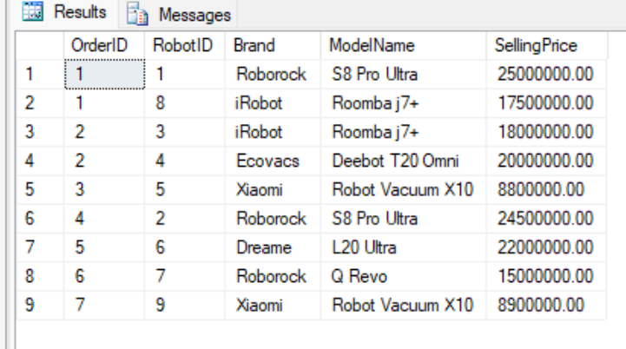
3. Robots in stock with model information
JOIN RobotUnit with RobotModel to display brand, model name, and status.
SELECT ru.RobotID, ru.SerialNumber, rm.Brand, rm.ModelName, ru.Status
FROM RobotUnit ru
JOIN RobotModel rm ON ru.ModelID = rm.ModelID;
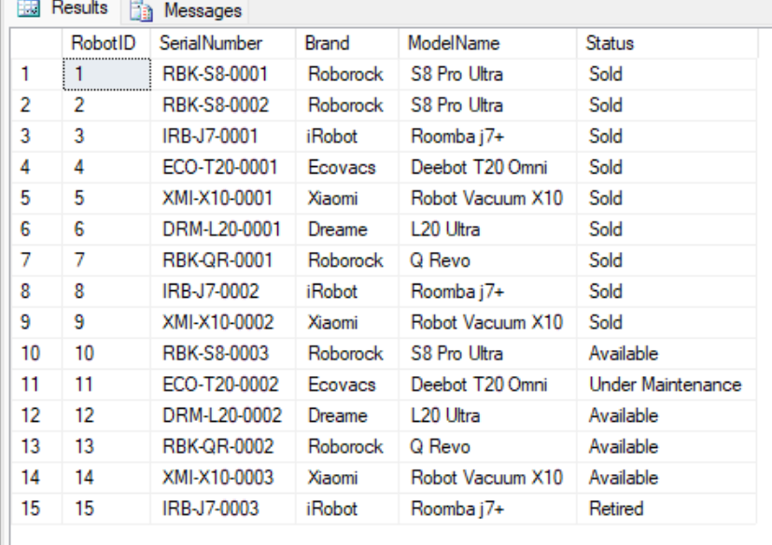
4. Service requests with customer name and robot serial
JOIN ServiceRequest with Customer and RobotUnit to see who submitted a request for which robot.
SELECT sr.RequestID, c.FullName AS Customer, ru.SerialNumber,
sr.IssueDescription, sr.Status
FROM ServiceRequest sr
JOIN Customer c ON sr.CustomerID = c.CustomerID
JOIN RobotUnit ru ON sr.RobotID = ru.RobotID;
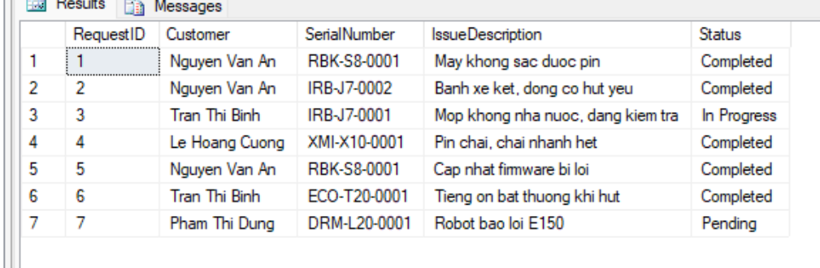
5. Maintenance history with the assigned technician
JOIN MaintenanceRecord -> ServiceRequest -> Employee to link each maintenance with its issue and technician.
SELECT mr.RecordID, sr.IssueDescription, e.FullName AS Technician,
mr.ServiceFee, mr.CompletionDate
FROM MaintenanceRecord mr
JOIN ServiceRequest sr ON mr.RequestID = sr.RequestID
JOIN Employee e ON mr.TechnicianID = e.EmployeeID;
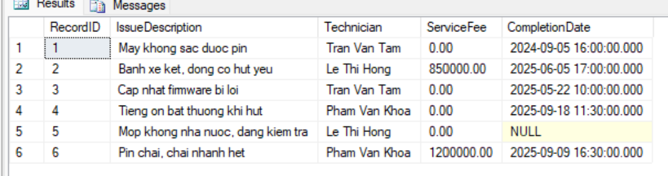
6. Full warranty information
JOIN WarrantyRegistration with RobotUnit, RobotModel and Customer.
SELECT w.WarrantyID, c.FullName AS Owner, rm.ModelName,
ru.SerialNumber, w.StartDate, w.EndDate
FROM WarrantyRegistration w
JOIN RobotUnit ru ON w.RobotID = ru.RobotID
JOIN RobotModel rm ON ru.ModelID = rm.ModelID
JOIN Customer c ON w.CustomerID = c.CustomerID;
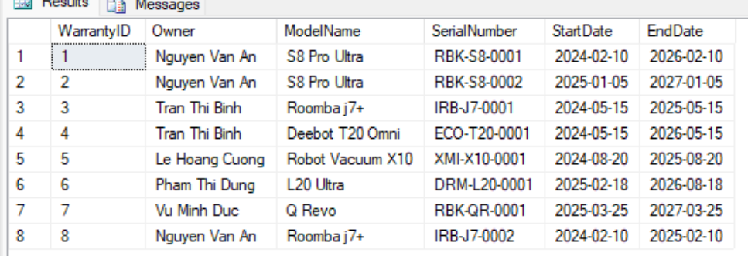
7. Payments for sales orders
JOIN Payment -> OrderPayment -> SalesOrder to know which order each payment corresponds to.
SELECT p.PaymentID, p.Amount, p.PaymentMethod, op.OrderID, so.OrderStatus
FROM Payment p
JOIN OrderPayment op ON p.PaymentID = op.PaymentID
JOIN SalesOrder so ON op.OrderID = so.OrderID;
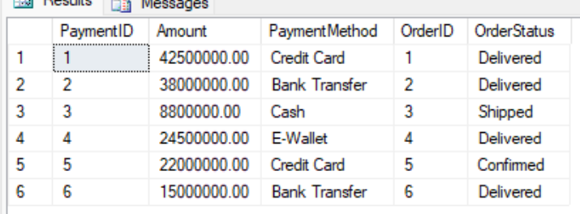
8. Payments for maintenance services
JOIN Payment -> ServicePayment -> MaintenanceRecord to see which maintenance a payment is for.
SELECT p.PaymentID, p.Amount, p.PaymentMethod, sp.ServiceRecordID, mr.ActionsTaken
FROM Payment p
JOIN ServicePayment sp ON p.PaymentID = sp.PaymentID
JOIN MaintenanceRecord mr ON sp.ServiceRecordID = mr.RecordID;
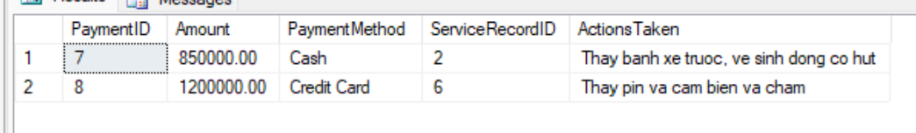
9. IoT logs with robot model
JOIN DeviceLog -> RobotUnit -> RobotModel to associate each log with its robot model.
SELECT dl.LogID, rm.ModelName, dl.LogTime, dl.ErrorCode
FROM DeviceLog dl
JOIN RobotUnit ru ON dl.RobotID = ru.RobotID
JOIN RobotModel rm ON ru.ModelID = rm.ModelID;
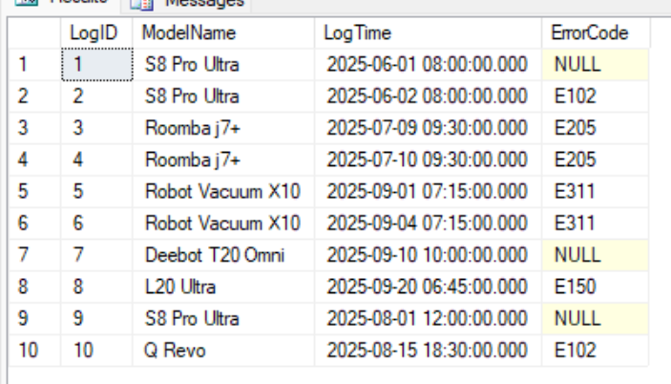
10. All orders including those without line items (LEFT JOIN)
LEFT JOIN SalesOrder with OrderDetail: cancelled orders (without line items) still appear with NULL values.
SELECT so.OrderID, so.OrderStatus, od.RobotID, od.SellingPrice
FROM SalesOrder so
LEFT JOIN OrderDetail od ON so.OrderID = od.OrderID
ORDER BY so.OrderID;
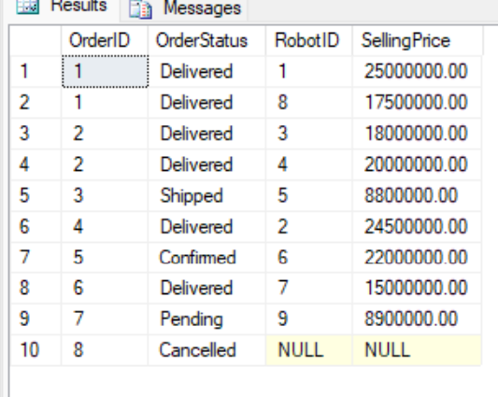
11. All customers including those who never bought (LEFT JOIN)
LEFT JOIN Customer with SalesOrder to also find customers who have not placed any order.
SELECT c.CustomerID, c.FullName, so.OrderID
FROM Customer c
LEFT JOIN SalesOrder so ON c.CustomerID = so.CustomerID
ORDER BY c.CustomerID;
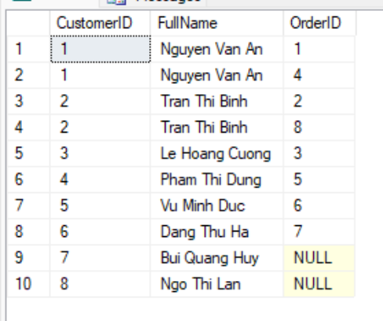
12. Features of each robot model
JOIN RobotModel with ModelFeature to list features per model.
SELECT rm.ModelName, mf.Feature
FROM RobotModel rm
JOIN ModelFeature mf ON rm.ModelID = mf.ModelID
ORDER BY rm.ModelName;
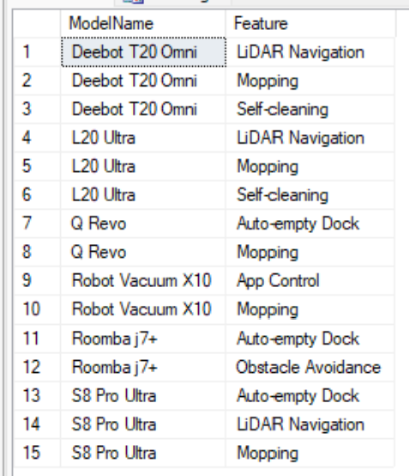

Grouping with GROUP BY and HAVING
1. Number of robots per model
GROUP BY ModelID, counting the robot units in stock for each model.
SELECT rm.ModelName, COUNT(ru.RobotID) AS Quantity
FROM RobotModel rm
JOIN RobotUnit ru ON rm.ModelID = ru.ModelID
GROUP BY rm.ModelName;
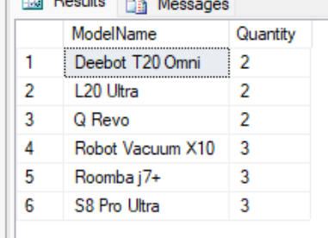
2. Number of robots per status
GROUP BY Status to summarize inventory (Available/Sold/Under Maintenance/Retired).
SELECT Status, COUNT(*) AS Quantity
FROM RobotUnit
GROUP BY Status;
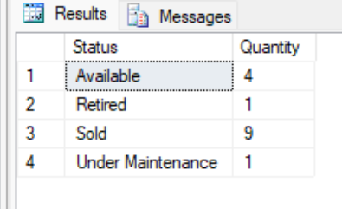
3. Total spending per customer
GROUP BY customer, computing the total order value.
SELECT c.FullName, SUM(so.TotalAmount) AS TotalSpending
FROM Customer c
JOIN SalesOrder so ON c.CustomerID = so.CustomerID
GROUP BY c.FullName
ORDER BY TotalSpending DESC;
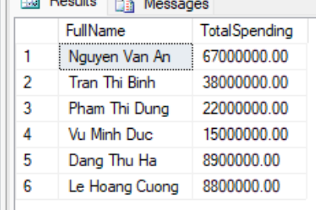
4. Number of orders handled by each salesperson
GROUP BY employee to count the orders handled.
SELECT e.FullName, COUNT(so.OrderID) AS OrderCount
FROM Employee e
JOIN SalesOrder so ON e.EmployeeID = so.EmployeeID
GROUP BY e.FullName;
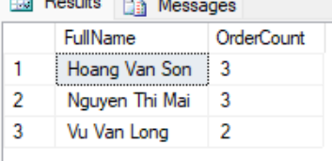
5. Total sales per order (from line items)
GROUP BY OrderID on OrderDetail to compute the actual total selling price of each order.
SELECT OrderID, COUNT(RobotID) AS RobotCount, SUM(SellingPrice) AS TotalAmount
FROM OrderDetail
GROUP BY OrderID;
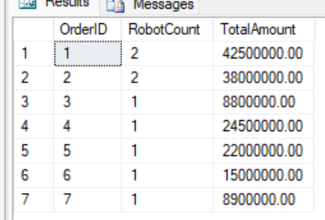
6. Number of robots sold per model
JOIN and GROUP BY to count the robots sold for each model.
SELECT rm.ModelName, COUNT(od.RobotID) AS SoldCount
FROM RobotModel rm
JOIN RobotUnit ru ON rm.ModelID = ru.ModelID
JOIN OrderDetail od ON ru.RobotID = od.RobotID
GROUP BY rm.ModelName;
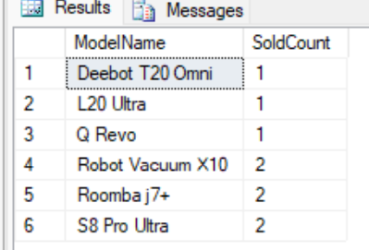
7. Number of service requests per status
GROUP BY Status on ServiceRequest.
SELECT Status, COUNT(*) AS RequestCount
FROM ServiceRequest
GROUP BY Status;
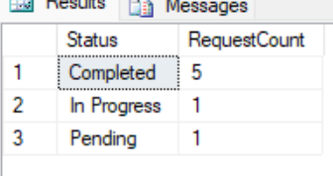
8. Robots sent for maintenance 2 or more times (HAVING)
GROUP BY RobotID and filter HAVING COUNT >= 2 to find robots that frequently fail.
SELECT RobotID, COUNT(*) AS RequestCount
FROM ServiceRequest
GROUP BY RobotID
HAVING COUNT(*) >= 2;
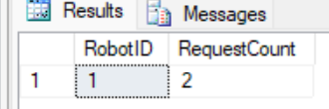
9. Total service fee per technician
GROUP BY technician to compute the total fee earned from maintenance work.
SELECT e.FullName, COUNT(mr.RecordID) AS MaintenanceCount, SUM(mr.ServiceFee) AS TotalFee
FROM Employee e
JOIN MaintenanceRecord mr ON e.EmployeeID = mr.TechnicianID
GROUP BY e.FullName;
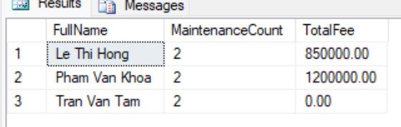
10. Number of features per robot model
GROUP BY model to count features.
SELECT rm.ModelName, COUNT(mf.Feature) AS FeatureCount
FROM RobotModel rm
JOIN ModelFeature mf ON rm.ModelID = mf.ModelID
GROUP BY rm.ModelName;
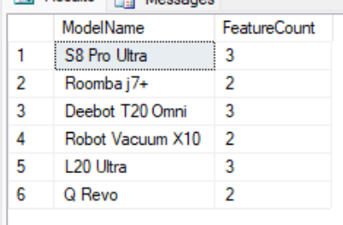
11. Robot models with more than 2 units in stock (HAVING)
GROUP BY model and filter HAVING COUNT > 2.
SELECT rm.ModelName, COUNT(ru.RobotID) AS Quantity
FROM RobotModel rm
JOIN RobotUnit ru ON rm.ModelID = ru.ModelID
GROUP BY rm.ModelName
HAVING COUNT(ru.RobotID) > 2;
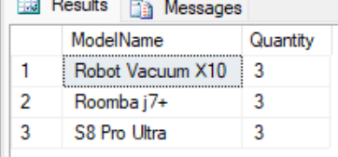
12. Customers spending more than 30 million (HAVING)
GROUP BY customer and use HAVING to filter big spenders.
SELECT c.FullName, SUM(so.TotalAmount) AS TotalSpending
FROM Customer c
JOIN SalesOrder so ON c.CustomerID = so.CustomerID
GROUP BY c.FullName
HAVING SUM(so.TotalAmount) > 30000000;
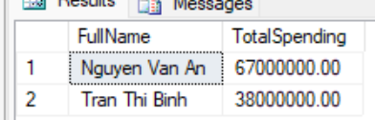

Subqueries in WHERE / FROM
1. Customers who have placed an order
Subquery in IN: get customers whose CustomerID appears in SalesOrder.
SELECT CustomerID, FullName
FROM Customer
WHERE CustomerID IN (SELECT CustomerID FROM SalesOrder);
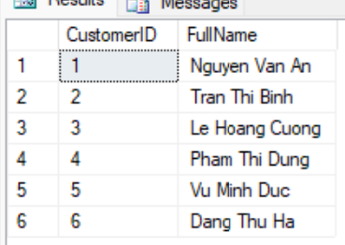
2. Robots never sold
Subquery NOT IN: robots not present in the OrderDetail table.
SELECT RobotID, SerialNumber, Status
FROM RobotUnit
WHERE RobotID NOT IN (SELECT RobotID FROM OrderDetail);
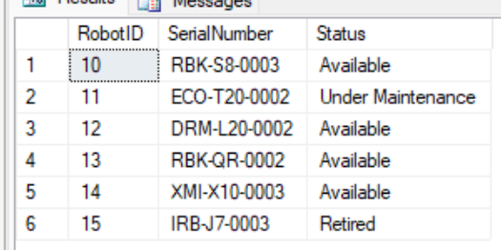
3. Robot models more expensive than average
Scalar subquery: compare UnitPrice with the catalog-wide average price.
SELECT ModelName, UnitPrice
FROM RobotModel
WHERE UnitPrice > (SELECT AVG(UnitPrice) FROM RobotModel);
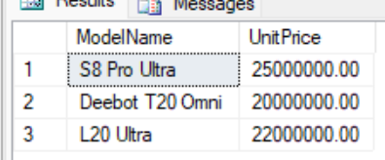
4. Orders larger than the average value
Scalar subquery computing AVG(TotalAmount) then filtering.
SELECT OrderID, TotalAmount
FROM SalesOrder
WHERE TotalAmount > (SELECT AVG(TotalAmount) FROM SalesOrder);
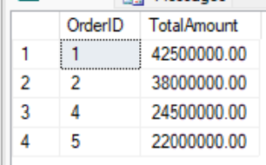
5. Customers who never requested service
Subquery NOT IN on ServiceRequest.
SELECT CustomerID, FullName
FROM Customer
WHERE CustomerID NOT IN (SELECT CustomerID FROM ServiceRequest);
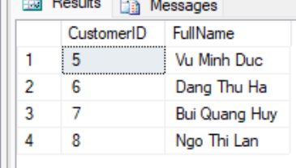
6. Employees who have performed maintenance
Subquery IN on MaintenanceRecord to get technicians who have work.
SELECT EmployeeID, FullName, Role
FROM Employee
WHERE EmployeeID IN (SELECT TechnicianID FROM MaintenanceRecord);
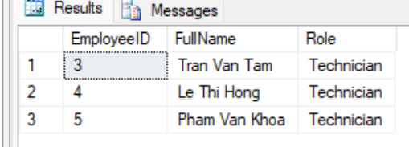
7. Revenue per customer (subquery in FROM)
Use a derived table to compute total spending then filter spenders > 20 million.
SELECT t.CustomerID, c.FullName, t.TotalSpending
FROM (SELECT CustomerID, SUM(TotalAmount) AS TotalSpending
FROM SalesOrder GROUP BY CustomerID) t
JOIN Customer c ON t.CustomerID = c.CustomerID
WHERE t.TotalSpending > 20000000;
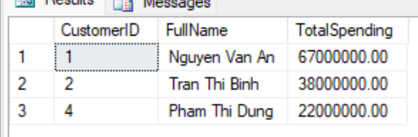
8. Robots currently under warranty
Subquery IN on WarrantyRegistration.
SELECT RobotID, SerialNumber
FROM RobotUnit
WHERE RobotID IN (SELECT RobotID FROM WarrantyRegistration);
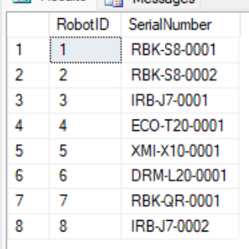
9. The most recent order
Scalar subquery using MAX(OrderDate) in WHERE.
SELECT OrderID, OrderDate, TotalAmount
FROM SalesOrder
WHERE OrderDate = (SELECT MAX(OrderDate) FROM SalesOrder);
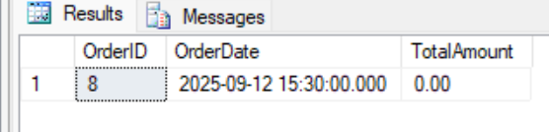
10. Robot models with no "Available" unit left
Subquery NOT IN: models not appearing in the set of models that have Available robots.
SELECT ModelID, ModelName
FROM RobotModel
WHERE ModelID NOT IN (
SELECT ModelID FROM RobotUnit WHERE Status = N'Available'
);
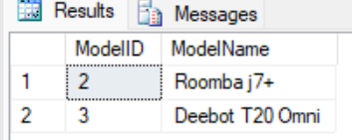

3.3. Advanced Queries

Nested subqueries
1. Customers who bought a Roborock-brand robot
4-level nesting: RobotModel(Brand) -> RobotUnit -> OrderDetail -> SalesOrder to trace back to the customer.
SELECT CustomerID, FullName
FROM Customer
WHERE CustomerID IN (
SELECT CustomerID FROM SalesOrder
WHERE OrderID IN (
SELECT OrderID FROM OrderDetail
WHERE RobotID IN (
SELECT RobotID FROM RobotUnit
WHERE ModelID IN (
SELECT ModelID FROM RobotModel WHERE Brand = N'Roborock'
)
)
)
);
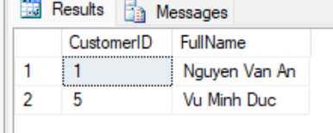
2. Robots that incurred a paid maintenance cost
2-level nesting: MaintenanceRecord(fee>0) -> ServiceRequest to get the RobotID.
SELECT RobotID, SerialNumber
FROM RobotUnit
WHERE RobotID IN (
SELECT RobotID FROM ServiceRequest
WHERE RequestID IN (
SELECT RequestID FROM MaintenanceRecord WHERE ServiceFee > 0
)
);
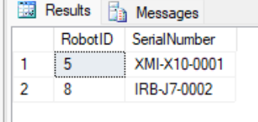
3. Technicians who repaired an iRobot-brand robot
Multi-level nesting through MaintenanceRecord -> ServiceRequest -> RobotUnit -> RobotModel(Brand).
SELECT EmployeeID, FullName
FROM Employee
WHERE EmployeeID IN (
SELECT TechnicianID FROM MaintenanceRecord
WHERE RequestID IN (
SELECT RequestID FROM ServiceRequest
WHERE RobotID IN (
SELECT RobotID FROM RobotUnit
WHERE ModelID IN (
SELECT ModelID FROM RobotModel WHERE Brand = N'iRobot'
)
)
)
);
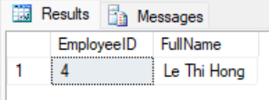
4. Robot models that currently have a unit under maintenance
Nested subquery: get the ModelID of robots with Status = Under Maintenance.
SELECT ModelID, ModelName
FROM RobotModel
WHERE ModelID IN (
SELECT ModelID FROM RobotUnit WHERE Status = N'Under Maintenance'
);
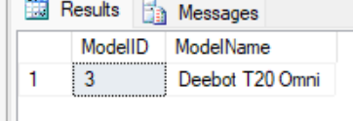
5. Customers with a robot still under valid warranty
Nested subquery combining the expiry-date condition with the list of sold robots.
SELECT CustomerID, FullName
FROM Customer
WHERE CustomerID IN (
SELECT CustomerID FROM WarrantyRegistration
WHERE EndDate >= CAST(GETDATE() AS DATE)
);
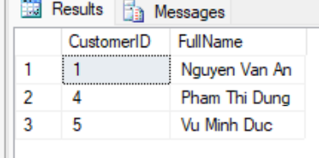
6. Customers spending above the average per customer
Nested subquery: compare a customer's total spending with the average of all customers' total spending.
SELECT c.FullName, SUM(so.TotalAmount) AS TotalSpending
FROM Customer c
JOIN SalesOrder so ON c.CustomerID = so.CustomerID
GROUP BY c.FullName
HAVING SUM(so.TotalAmount) > (
SELECT AVG(t.Total)
FROM (SELECT SUM(TotalAmount) AS Total FROM SalesOrder GROUP BY CustomerID) t
);
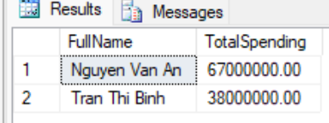

Using EXISTS, IN, ANY/ALL
1. Customers who have placed an order (EXISTS)
Correlated EXISTS: at least one order exists for the customer under consideration.
SELECT c.CustomerID, c.FullName
FROM Customer c
WHERE EXISTS (SELECT 1 FROM SalesOrder so WHERE so.CustomerID = c.CustomerID);
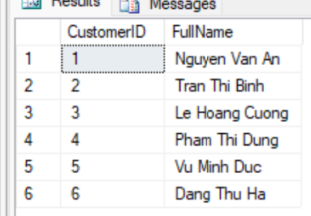
2. Robots that have never sent any IoT log (NOT EXISTS)
NOT EXISTS: no log row exists in DeviceLog for the robot under consideration.
SELECT ru.RobotID, ru.SerialNumber
FROM RobotUnit ru
WHERE NOT EXISTS (SELECT 1 FROM DeviceLog dl WHERE dl.RobotID = ru.RobotID);
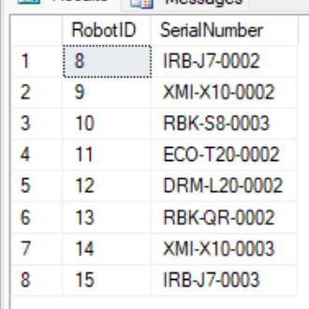
3. Robot models with at least 1 available unit (correlated EXISTS)
Correlated EXISTS with RobotUnit Status = Available.
SELECT rm.ModelID, rm.ModelName
FROM RobotModel rm
WHERE EXISTS (
SELECT 1 FROM RobotUnit ru
WHERE ru.ModelID = rm.ModelID AND ru.Status = N'Available'
);
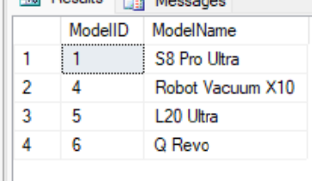
4. Robots sold in delivered orders (IN)
IN with a subquery filtering OrderIDs that have Delivered status.
SELECT RobotID, OrderID, SellingPrice
FROM OrderDetail
WHERE OrderID IN (SELECT OrderID FROM SalesOrder WHERE OrderStatus = N'Delivered');
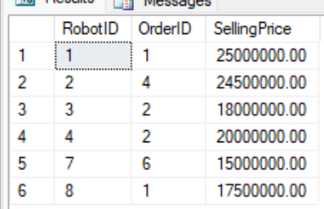
5. Robot models more expensive than at least 1 Roborock model (ANY)
> ANY: price greater than the lowest price among Roborock models.
SELECT ModelName, UnitPrice
FROM RobotModel
WHERE UnitPrice > ANY (SELECT UnitPrice FROM RobotModel WHERE Brand = N'Roborock');
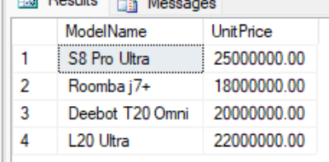
6. The most expensive robot model (>= ALL)
>= ALL: price greater than or equal to all others, i.e. the most expensive model.
SELECT ModelName, UnitPrice
FROM RobotModel
WHERE UnitPrice >= ALL (SELECT UnitPrice FROM RobotModel);
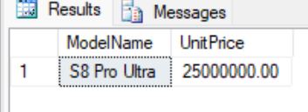

Set operations (UNION / INTERSECT / EXCEPT)
1. Combined contact directory (UNION)
UNION merges names + emails of customers and employees into a single directory (duplicates removed).
SELECT FullName, Email, N'Customer' AS ContactType FROM Customer
UNION
SELECT FullName, Email, N'Employee' FROM Employee;
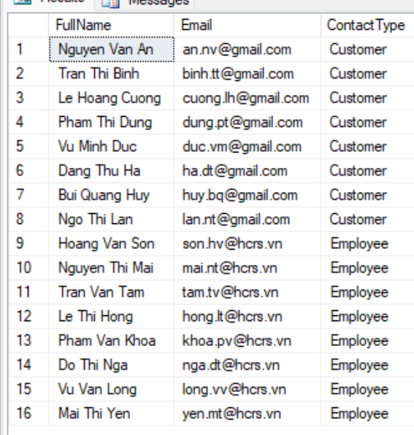
2. Customer IDs with any transaction (UNION)
UNION of CustomerIDs from orders and from service requests (union of the two sets).
SELECT CustomerID FROM SalesOrder
UNION
SELECT CustomerID FROM ServiceRequest;
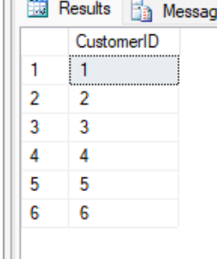
3. Customers who both bought and requested service (INTERSECT)
INTERSECT: the intersection of customers with orders and customers with service requests.
SELECT CustomerID FROM SalesOrder
INTERSECT
SELECT CustomerID FROM ServiceRequest;
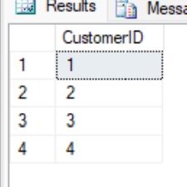
4. Customers who bought but never requested service (EXCEPT)
EXCEPT: customers with orders minus customers with service requests.
SELECT CustomerID FROM SalesOrder
EXCEPT
SELECT CustomerID FROM ServiceRequest;
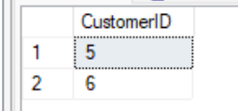
5. Robots never sold (EXCEPT)
EXCEPT: all robots minus robots that appear in OrderDetail.
SELECT RobotID FROM RobotUnit
EXCEPT
SELECT RobotID FROM OrderDetail;
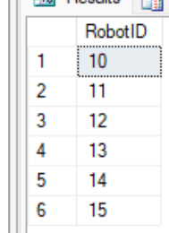
6. Robots with both IoT logs and service requests (INTERSECT)
INTERSECT: the intersection of robots with logs and robots with service requests.
SELECT RobotID FROM DeviceLog
INTERSECT
SELECT RobotID FROM ServiceRequest;
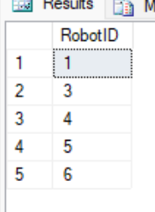

4. Functions
1. fn_GetWarrantyStatus - check the warranty status of a robot
A scalar function that takes a RobotID and returns "Under Warranty", "Warranty Expired" or "No Warranty" by comparing EndDate with the current date.
GO
CREATE FUNCTION dbo.fn_GetWarrantyStatus (@RobotID INT)
RETURNS NVARCHAR(30)
AS
BEGIN
DECLARE @End DATE;
SELECT @End = EndDate FROM WarrantyRegistration WHERE RobotID = @RobotID;
IF @End IS NULL
RETURN N'No Warranty';
IF @End >= CAST(GETDATE() AS DATE)
RETURN N'Under Warranty';
RETURN N'Warranty Expired';
END;
GO
-- Demo: apply the function to each sold robot
SELECT RobotID, SerialNumber, dbo.fn_GetWarrantyStatus(RobotID) AS WarrantyStatus
FROM RobotUnit
WHERE Status <> N'Available';
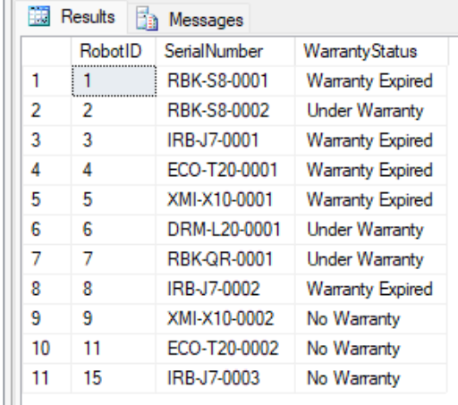
2. fn_GetCustomerTotalSpending - total spending of a customer
A scalar function computing the total amount a customer has paid for orders (via Payment + OrderPayment). Uses ISNULL to return 0 if the customer has not paid.
GO
CREATE FUNCTION dbo.fn_GetCustomerTotalSpending (@CustomerID INT)
RETURNS DECIMAL(18,2)
AS
BEGIN
DECLARE @Total DECIMAL(18,2);
SELECT @Total = SUM(p.Amount)
FROM Payment p
JOIN OrderPayment op ON p.PaymentID = op.PaymentID
JOIN SalesOrder so ON op.OrderID = so.OrderID
WHERE so.CustomerID = @CustomerID;
RETURN ISNULL(@Total, 0);
END;
GO
-- Demo: list the total spending of each customer
SELECT CustomerID, FullName, dbo.fn_GetCustomerTotalSpending(CustomerID) AS TotalSpending
FROM Customer
ORDER BY TotalSpending DESC;
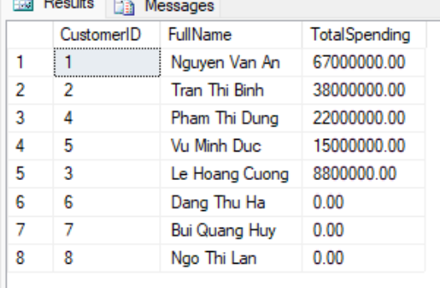
3. fn_GetModelAvailableUnits - number of available units of a model
A scalar function returning the number of robots in Available status for a model, helping salespeople check stock quickly.
GO
CREATE FUNCTION dbo.fn_GetModelAvailableUnits (@ModelID INT)
RETURNS INT
AS
BEGIN
DECLARE @Cnt INT;
SELECT @Cnt = COUNT(*)
FROM RobotUnit
WHERE ModelID = @ModelID AND Status = N'Available';
RETURN @Cnt;
END;
GO
-- Demo: available stock per model
SELECT ModelID, ModelName, dbo.fn_GetModelAvailableUnits(ModelID) AS AvailableUnits
FROM RobotModel;
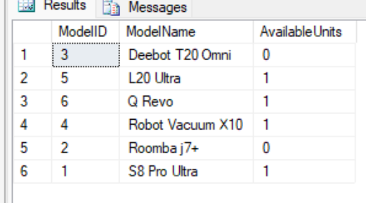
4. fn_GetMaintenanceHistoryByRobot - maintenance history of a robot (table-valued)
An inline table-valued function listing the entire maintenance history of a robot, including the issue, technician, and service fee.
GO
CREATE FUNCTION dbo.fn_GetMaintenanceHistoryByRobot (@RobotID INT)
RETURNS TABLE
AS
RETURN
(
SELECT mr.RecordID, sr.RequestID, sr.IssueDescription,
e.FullName AS Technician, mr.ServiceFee, mr.CompletionDate
FROM MaintenanceRecord mr
JOIN ServiceRequest sr ON mr.RequestID = sr.RequestID
JOIN Employee e ON mr.TechnicianID = e.EmployeeID
WHERE sr.RobotID = @RobotID
);
GO
-- Demo: maintenance history of robot RobotID = 1
SELECT * FROM dbo.fn_GetMaintenanceHistoryByRobot(1);
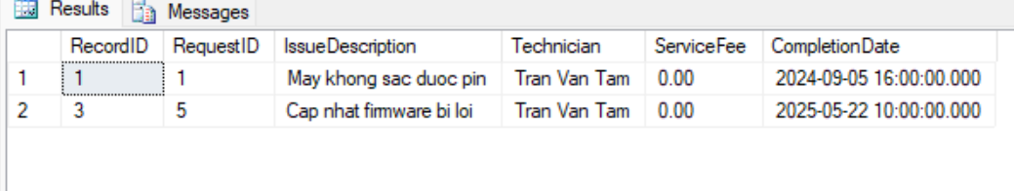

5. Stored Procedures
1. sp_CreateSalesOrder - create a complete sales order
A multi-step procedure within a transaction: check that the robot is available, create the SalesOrder, add OrderDetail, create Payment and OrderPayment, and update inventory (robot -> Sold). Uses TRY/CATCH to roll back on error.
GO
CREATE PROCEDURE sp_CreateSalesOrder
@CustomerID INT,
@EmployeeID INT,
@RobotID INT,
@SellingPrice DECIMAL(18,2),
@PaymentMethod NVARCHAR(30)
AS
BEGIN
SET NOCOUNT ON;
BEGIN TRY
BEGIN TRANSACTION;

IF NOT EXISTS (SELECT 1 FROM RobotUnit WHERE RobotID = @RobotID AND Status = N'Available')
BEGIN
-- RAISERROR requires (Message, Severity, State)
RAISERROR (N'Robot does not exist or is no longer available for sale.', 16, 1);
ROLLBACK TRANSACTION; -- Must rollback manually if we don't jump to CATCH
RETURN;
END

DECLARE @OrderID INT, @PaymentID INT;

INSERT INTO SalesOrder (CustomerID, EmployeeID, TotalAmount, OrderStatus)
VALUES (@CustomerID, @EmployeeID, @SellingPrice, N'Confirmed');
SET @OrderID = SCOPE_IDENTITY();

INSERT INTO OrderDetail (RobotID, OrderID, SellingPrice)
VALUES (@RobotID, @OrderID, @SellingPrice);

UPDATE RobotUnit SET Status = N'Sold' WHERE RobotID = @RobotID;

INSERT INTO Payment (Amount, PaymentMethod) VALUES (@SellingPrice, @PaymentMethod);
SET @PaymentID = SCOPE_IDENTITY();
INSERT INTO OrderPayment (PaymentID, OrderID) VALUES (@PaymentID, @OrderID);

COMMIT TRANSACTION;
SELECT @OrderID AS NewOrderID, @PaymentID AS NewPaymentID;
END TRY
BEGIN CATCH
IF @@TRANCOUNT > 0 ROLLBACK TRANSACTION;
-- Re-throw the original error info
DECLARE @ErrMsg NVARCHAR(4000) = ERROR_MESSAGE();
DECLARE @ErrSev INT = ERROR_SEVERITY();
DECLARE @ErrState INT = ERROR_STATE();
RAISERROR(@ErrMsg, @ErrSev, @ErrState);
END CATCH
END;
GO
-- Demo: sell robot RobotID = 10 (Available) to customer 7
EXEC sp_CreateSalesOrder @CustomerID = 7, @EmployeeID = 1, @RobotID = 10,
@SellingPrice = 24000000, @PaymentMethod = N'Credit Card';
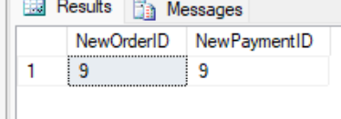
2. sp_RegisterWarranty - register a warranty for a sold robot
A procedure that automatically computes the warranty end date from the model's duration (months). Prevents duplicate registration and checks that the robot exists.
GO
CREATE PROCEDURE sp_RegisterWarranty
@RobotID INT,
@CustomerID INT,
@StartDate DATE = NULL
AS
BEGIN
SET NOCOUNT ON;
IF @StartDate IS NULL SET @StartDate = CAST(GETDATE() AS DATE);
IF EXISTS (SELECT 1 FROM WarrantyRegistration WHERE RobotID = @RobotID)
BEGIN
RAISERROR (N'This robot already has a warranty registration.', 16, 1);
RETURN;
END
DECLARE @Months INT;
SELECT @Months = rm.WarrantyDuration
FROM RobotUnit ru
JOIN RobotModel rm ON ru.ModelID = rm.ModelID
WHERE ru.RobotID = @RobotID;
IF @Months IS NULL
BEGIN
RAISERROR (N'Robot does not exist in the system.', 16, 1);
RETURN;
END
DECLARE @End DATE = DATEADD(MONTH, @Months, @StartDate);
INSERT INTO WarrantyRegistration (RobotID, CustomerID, StartDate, EndDate)
VALUES (@RobotID, @CustomerID, @StartDate, @End);
SELECT @RobotID AS RobotID, @StartDate AS StartDate, @End AS EndDate;
END;
GO
-- Demo: register a warranty for robot 10 just sold to customer 7
EXEC sp_RegisterWarranty @RobotID = 10, @CustomerID = 7;
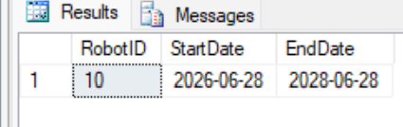
3. sp_CompleteMaintenance - record completion of maintenance
A multi-step procedure: check the service request, waive the fee if the robot is under warranty, create a MaintenanceRecord, update the request status to Completed, and create a service payment if a fee applies. Reuses the fn_GetWarrantyStatus function.
GO
CREATE PROCEDURE sp_CompleteMaintenance
@RequestID INT,
@TechnicianID INT,
@ActionsTaken NVARCHAR(MAX),
@BaseFee DECIMAL(18,2),
@PaymentMethod NVARCHAR(30) = N'Cash'
AS
BEGIN
SET NOCOUNT ON;
BEGIN TRY
BEGIN TRANSACTION;

-- Check if request exists
IF NOT EXISTS (SELECT 1 FROM ServiceRequest WHERE RequestID = @RequestID)
BEGIN
RAISERROR (N'Service request does not exist.', 16, 1);
ROLLBACK TRANSACTION;
RETURN;
END

-- Check if record already exists
IF EXISTS (SELECT 1 FROM MaintenanceRecord WHERE RequestID = @RequestID)
BEGIN
RAISERROR (N'This request already has a maintenance record.', 16, 1);
ROLLBACK TRANSACTION;
RETURN;
END

DECLARE @RobotID INT;
SELECT @RobotID = RobotID FROM ServiceRequest WHERE RequestID = @RequestID;

-- Calculate Fee based on warranty
DECLARE @Fee DECIMAL(18,2) = @BaseFee;
IF dbo.fn_GetWarrantyStatus(@RobotID) = N'Under Warranty'
SET @Fee = 0;

DECLARE @RecordID INT;
INSERT INTO MaintenanceRecord (RequestID, TechnicianID, ActionsTaken, ServiceFee, CompletionDate)
VALUES (@RequestID, @TechnicianID, @ActionsTaken, @Fee, GETDATE());
SET @RecordID = SCOPE_IDENTITY();

UPDATE ServiceRequest SET Status = N'Completed' WHERE RequestID = @RequestID;

-- Process payment if fee is applicable
IF @Fee > 0
BEGIN
DECLARE @PaymentID INT;
INSERT INTO Payment (Amount, PaymentMethod) VALUES (@Fee, @PaymentMethod);
SET @PaymentID = SCOPE_IDENTITY();
INSERT INTO ServicePayment (PaymentID, ServiceRecordID) VALUES (@PaymentID, @RecordID);
END

COMMIT TRANSACTION;
SELECT @RecordID AS NewRecordID, @Fee AS AppliedFee;
END TRY
BEGIN CATCH
IF @@TRANCOUNT > 0 ROLLBACK TRANSACTION;

-- Re-raise error using parameters retrieved from system functions
DECLARE @ErrMsg NVARCHAR(4000) = ERROR_MESSAGE();
DECLARE @ErrSev INT = ERROR_SEVERITY();
DECLARE @ErrState INT = ERROR_STATE();
RAISERROR(@ErrMsg, @ErrSev, @ErrState);
END CATCH
END;
GO
-- Demo: complete service request RequestID = 7 (robot 6 under warranty -> free)
EXEC sp_CompleteMaintenance @RequestID = 7, @TechnicianID = 5,
@ActionsTaken = N'Inspect and reset error E150', @BaseFee = 500000;
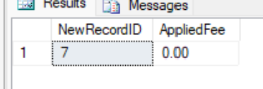
4. sp_GenerateSalesReport - revenue report by model & date range
A procedure that takes a date range and returns a summary report: units sold and revenue for each robot model within that range, sorted by revenue descending.
GO
CREATE PROCEDURE sp_GenerateSalesReport
@FromDate DATE,
@ToDate DATE
AS
BEGIN
SET NOCOUNT ON;
SELECT rm.Brand, rm.ModelName,
COUNT(od.RobotID) AS UnitsSold,
SUM(od.SellingPrice) AS Revenue
FROM OrderDetail od
JOIN SalesOrder so ON od.OrderID = so.OrderID
JOIN RobotUnit ru ON od.RobotID = ru.RobotID
JOIN RobotModel rm ON ru.ModelID = rm.ModelID
WHERE so.OrderDate >= @FromDate
AND so.OrderDate < DATEADD(DAY, 1, @ToDate)
GROUP BY rm.Brand, rm.ModelName
ORDER BY Revenue DESC;
END;
GO
-- Demo: revenue report from 01/2024 to 12/2025
EXEC sp_GenerateSalesReport @FromDate = '2024-01-01', @ToDate = '2025-12-31';
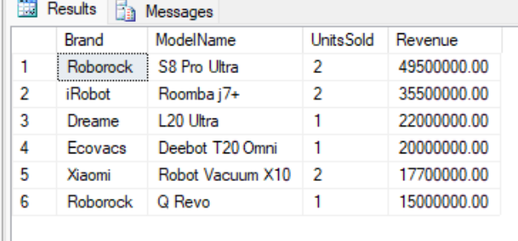

6. Triggers
1. trg_RobotUnit_AuditStatus - automatically log robot status changes
An AFTER UPDATE trigger on RobotUnit: whenever the Status column changes, it automatically writes a row into the RobotStatusAudit table (old status -> new status, timestamp). It logs only when the values actually differ.
GO
CREATE TRIGGER trg_RobotUnit_AuditStatus ON RobotUnit
AFTER UPDATE
AS
BEGIN
SET NOCOUNT ON;
INSERT INTO RobotStatusAudit (RobotID, OldStatus, NewStatus)
SELECT i.RobotID, d.Status, i.Status
FROM inserted i
JOIN deleted d ON i.RobotID = d.RobotID
WHERE i.Status <> d.Status;
END;
GO
-- Demo: change robot 14 status (Available -> Retired) and view the audit log
UPDATE RobotUnit SET Status = N'Retired' WHERE RobotID = 14;
SELECT * FROM RobotStatusAudit WHERE RobotID = 14;
[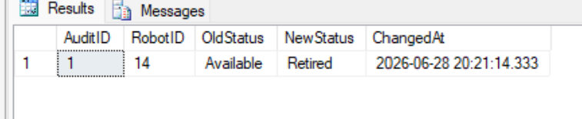]
2. trg_OrderDetail_AfterInsert - automatically update inventory after a sale
An AFTER INSERT trigger on OrderDetail: when a robot is added to an order line, it automatically changes that robot status to "Sold". This illustrates "updating inventory after a sales transaction".
GO
CREATE TRIGGER trg_OrderDetail_AfterInsert ON OrderDetail
AFTER INSERT
AS
BEGIN
SET NOCOUNT ON;
UPDATE ru
SET ru.Status = N'Sold'
FROM RobotUnit ru
JOIN inserted i ON ru.RobotID = i.RobotID
WHERE ru.Status <> N'Sold';
END;
GO
-- Demo: sell robot 12 (Available) by inserting OrderDetail directly
SELECT RobotID, Status AS BeforeSale FROM RobotUnit WHERE RobotID = 12;
DECLARE @demoOrder INT;
INSERT INTO SalesOrder (CustomerID, EmployeeID, TotalAmount, OrderStatus)
VALUES (2, 2, 22000000, N'Confirmed');
SET @demoOrder = SCOPE_IDENTITY();
INSERT INTO OrderDetail (RobotID, OrderID, SellingPrice) VALUES (12, @demoOrder, 22000000);
SELECT RobotID, Status AS AfterSale FROM RobotUnit WHERE RobotID = 12; -- -> Sold
SELECT * FROM RobotStatusAudit WHERE RobotID = 12; -- audit captured
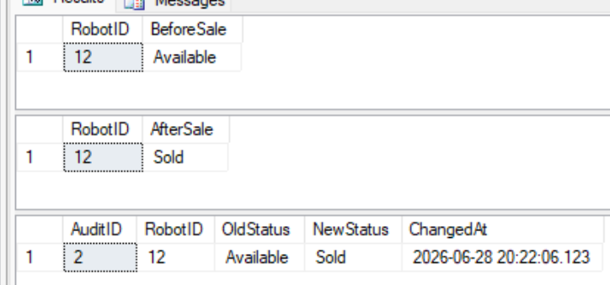
3. trg_PreventDeleteCustomerWithOrders - block deletion of referenced customers
An INSTEAD OF DELETE trigger on Customer: it disallows deleting a customer who still has orders or service requests (protecting parent records). It performs the delete only when valid.
GO
CREATE TRIGGER trg_PreventDeleteCustomerWithOrders ON Customer
INSTEAD OF DELETE
AS
BEGIN
SET NOCOUNT ON;
IF EXISTS (SELECT 1 FROM SalesOrder so JOIN deleted d ON so.CustomerID = d.CustomerID)
OR EXISTS (SELECT 1 FROM ServiceRequest sr JOIN deleted d ON sr.CustomerID = d.CustomerID)
BEGIN
RAISERROR(N'Cannot delete a customer who has orders or service requests.', 16, 1);
RETURN;
END
DELETE FROM Customer WHERE CustomerID IN (SELECT CustomerID FROM deleted);
END;
GO
-- Demo: (a) delete an unreferenced customer -> success; (b) delete a customer with orders -> blocked
INSERT INTO Customer (FullName, PhoneNumber, Email, Password)
VALUES (N'Temp Demo Customer', '0900000099', N'tam.demo@gmail.com', N'temp');
DELETE FROM Customer WHERE Email = N'tam.demo@gmail.com'; -- success
BEGIN TRY
DELETE FROM Customer WHERE CustomerID = 1; -- blocked by trigger
END TRY
BEGIN CATCH
PRINT ERROR_MESSAGE();
END CATCH
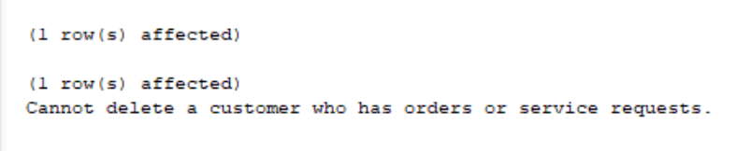
4. trg_Maintenance_AfterInsert - apply the warranty rule & sync status
An AFTER INSERT trigger on MaintenanceRecord: (1) if the robot is under warranty at the time of maintenance, it automatically sets ServiceFee = 0 (free under warranty); (2) when a completion date is present, it automatically updates the related service request to Completed status.
GO
CREATE TRIGGER trg_Maintenance_AfterInsert ON MaintenanceRecord
AFTER INSERT
AS
BEGIN
SET NOCOUNT ON;
UPDATE mr
SET mr.ServiceFee = 0
FROM MaintenanceRecord mr
JOIN inserted i ON mr.RecordID = i.RecordID
JOIN ServiceRequest sr ON i.RequestID = sr.RequestID
JOIN WarrantyRegistration w ON sr.RobotID = w.RobotID
WHERE i.ServiceFee > 0
AND CAST(GETDATE() AS DATE) BETWEEN w.StartDate AND w.EndDate;
UPDATE sr
SET sr.Status = N'Completed'
FROM ServiceRequest sr
JOIN inserted i ON sr.RequestID = i.RequestID
WHERE i.CompletionDate IS NOT NULL;
END;
GO
-- Demo: create a new request for robot 6 (under warranty) then insert a maintenance record with fee 600000
DECLARE @demoReq INT;
INSERT INTO ServiceRequest (RobotID, CustomerID, IssueDescription, Status)
VALUES (6, 4, N'Periodic maintenance within warranty', N'Assigned');
SET @demoReq = SCOPE_IDENTITY();
INSERT INTO MaintenanceRecord (RequestID, TechnicianID, ActionsTaken, ServiceFee, CompletionDate)
VALUES (@demoReq, 5, N'Periodic maintenance', 600000, GETDATE());
-- Result: ServiceFee set to 0 by the trigger (under warranty) and the request -> Completed
SELECT mr.RecordID, mr.ServiceFee, sr.Status
FROM MaintenanceRecord mr JOIN ServiceRequest sr ON mr.RequestID = sr.RequestID
WHERE mr.RequestID = @demoReq;
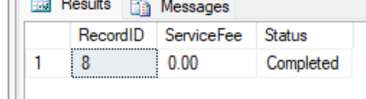

7. Views and Indexes

Views - simplifying complex queries
1. vw_RobotInventory - robot inventory with warranty status
A view aggregating each robot with brand, model name, price, status and warranty status (calling fn_GetWarrantyStatus). Helps staff look up inventory quickly.
GO
CREATE VIEW vw_RobotInventory AS
SELECT ru.RobotID, ru.SerialNumber, rm.Brand, rm.ModelName, rm.UnitPrice,
ru.Status, dbo.fn_GetWarrantyStatus(ru.RobotID) AS WarrantyStatus
FROM RobotUnit ru
JOIN RobotModel rm ON ru.ModelID = rm.ModelID;
GO
-- Demo: view the entire inventory through the view
SELECT * FROM vw_RobotInventory ORDER BY RobotID;
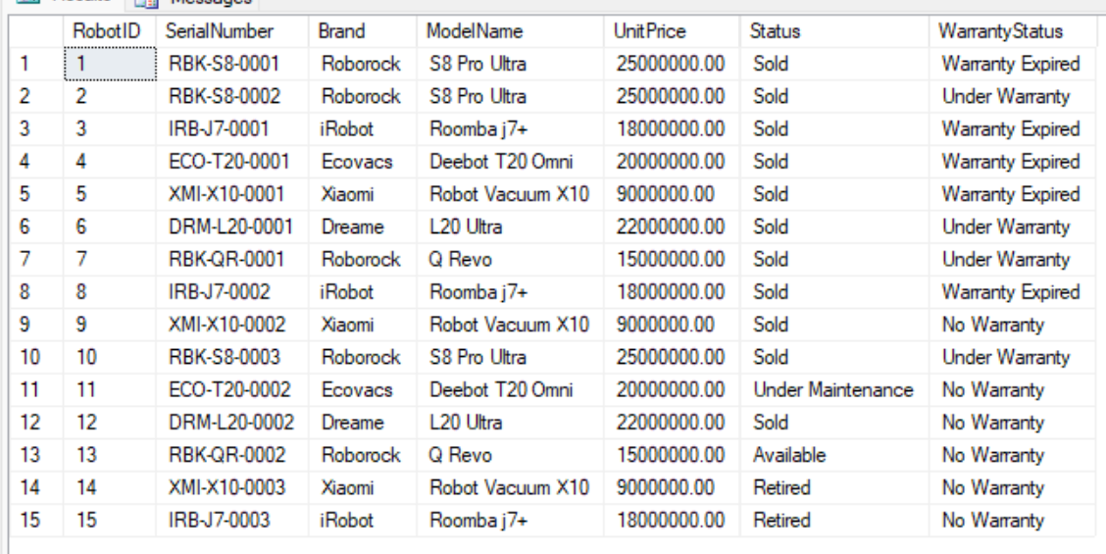
2. vw_SalesOrderSummary - order summary with amount paid
A view joining orders with customer name, salesperson and total amount paid (subquery), enabling sales reporting without rewriting complex JOINs.
GO
CREATE VIEW vw_SalesOrderSummary AS
SELECT so.OrderID, c.FullName AS CustomerName, e.FullName AS SalesStaff,
so.OrderDate, so.TotalAmount, so.OrderStatus,
ISNULL((SELECT SUM(p.Amount)
FROM OrderPayment op JOIN Payment p ON op.PaymentID = p.PaymentID
WHERE op.OrderID = so.OrderID), 0) AS PaidAmount
FROM SalesOrder so
JOIN Customer c ON so.CustomerID = c.CustomerID
JOIN Employee e ON so.EmployeeID = e.EmployeeID;
GO
-- Demo: view the summary of all orders
SELECT * FROM vw_SalesOrderSummary ORDER BY OrderID;
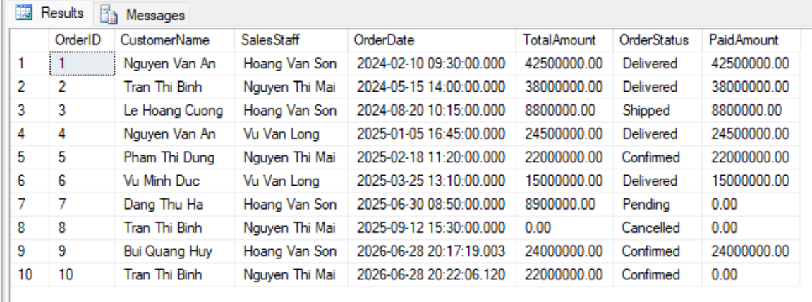
3. vw_MaintenanceDetails - full maintenance details
A view joining maintenance records with robot, customer, technician and issue description, helping managers track maintenance history by querying a single object.
GO
CREATE VIEW vw_MaintenanceDetails AS
SELECT mr.RecordID, ru.SerialNumber, rm.ModelName, c.FullName AS Customer,
tech.FullName AS Technician, sr.IssueDescription, mr.ServiceFee, mr.CompletionDate
FROM MaintenanceRecord mr
JOIN ServiceRequest sr ON mr.RequestID = sr.RequestID
JOIN RobotUnit ru ON sr.RobotID = ru.RobotID
JOIN RobotModel rm ON ru.ModelID = rm.ModelID
JOIN Customer c ON sr.CustomerID = c.CustomerID
JOIN Employee tech ON mr.TechnicianID = tech.EmployeeID;
GO
-- Demo: view maintenance details through the view
SELECT * FROM vw_MaintenanceDetails ORDER BY RecordID;
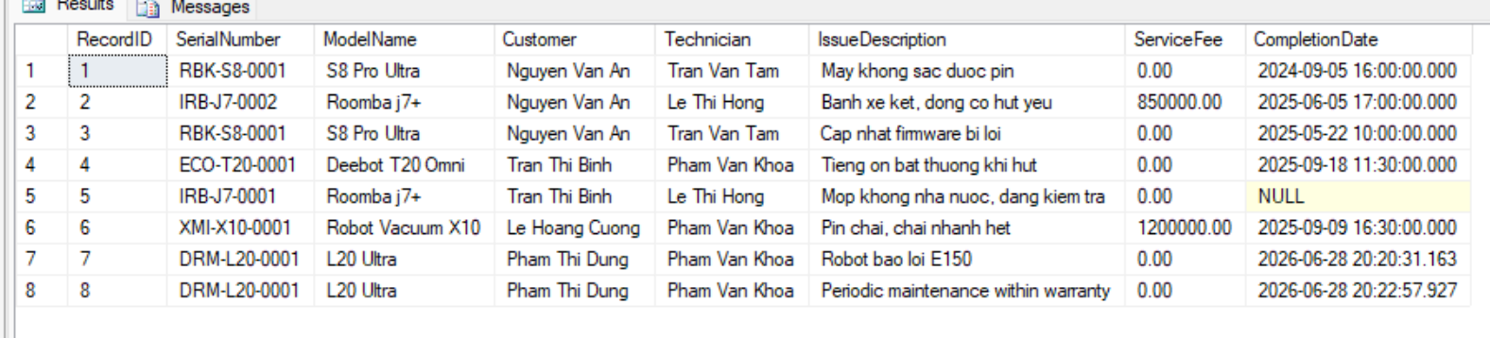

Indexes - speeding up queries
1. IX_RobotUnit_Status - single-column index
A non-clustered index on the single column RobotUnit(Status), speeding up queries that filter/aggregate by inventory status (e.g. counting Available robots).
GO
CREATE NONCLUSTERED INDEX IX_RobotUnit_Status ON RobotUnit(Status);
GO
-- Demo: a query that benefits from this index (see the Actual Execution Plan in SSMS)
SELECT RobotID, ModelID, SerialNumber FROM RobotUnit WHERE Status = N'Available';
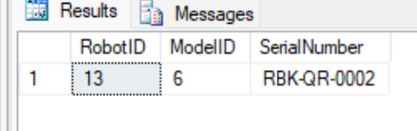
2. IX_SalesOrder_Customer_Date - composite index
A composite index on SalesOrder(CustomerID, OrderDate) optimizing queries that look up a customer orders within a date range (e.g. purchase history).
GO
CREATE NONCLUSTERED INDEX IX_SalesOrder_Customer_Date ON SalesOrder(CustomerID, OrderDate);
GO
-- Demo: a query filtering by customer and time
SELECT OrderID, OrderDate, TotalAmount
FROM SalesOrder
WHERE CustomerID = 1 AND OrderDate >= '2024-01-01'
ORDER BY OrderDate;
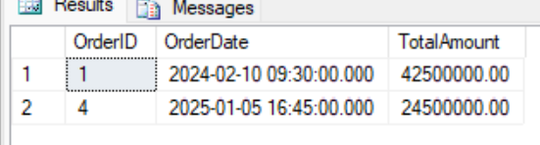
3. IX_ServiceRequest_Status - single-column index (additional)
An index on ServiceRequest(Status) helps speed up listing service requests awaiting handling (Pending/Assigned/In Progress).
GO
CREATE NONCLUSTERED INDEX IX_ServiceRequest_Status ON ServiceRequest(Status);
GO
-- Demo
SELECT RequestID, RobotID, RequestDate FROM ServiceRequest WHERE Status = N'Pending';
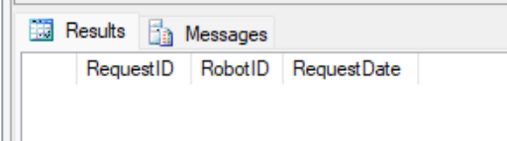

8. Conclusion and Reflection
Through Lab 5, the team has fully practiced SQL programming techniques on a realistic database for the household cleaning robot sales & maintenance system. From basic queries (SELECT, WHERE, ORDER BY, aggregate functions), to intermediate queries (JOIN, GROUP BY/HAVING, subqueries) and advanced queries (nested subqueries, EXISTS/IN/ANY/ALL, UNION/INTERSECT/EXCEPT), the team has explored the data from many business perspectives.
Key takeaways:
- Functions enable logic reuse ( checking warranty status, computing a customer total spending) and can be reused inside Views and Procedures.
- Stored Procedures encapsulate multi-step operations (creating a sales order, registering a warranty, completing maintenance) within transactions, ensuring data integrity when errors occur.
- Triggers enforce business rules at the database level: automatically updating inventory after a sale, logging status changes, preventing deletion of referenced parent records, and waiving service fees while under warranty.
- Views simplify complex queries, while Indexes (single-column and composite) improve the performance of filtering/sorting queries.
Combining constraints (Lab 4) with Functions/Procedures/Triggers (Lab 5) produces a database that is both structurally robust and capable of automating business logic, reducing dependence on the application layer and limiting data errors.

